
UNIVERSITI TEKNOLOGI MARA (UiTM)
CAWANGAN KEDAH, SUNGAI PETANI

DIPLOMA IN INFORMATICS LIBRARY
(IM 144)
PROGRAMMING FOR LIBRARIES
(IML 208)

GROUP PROJECT: LIBRARY MANAGEMENT SYSTEM (iLIBS)
PREPARED BY:
NAME | STUDENT ID
NINA SALINA BINTI SUZUKI | 2022971209
NUR SAKINAH BINTI JAMIRAN | 2022777155
NUR FADHILAH BINTI ARIFIN | 2022764227
NURUL JANNAH BINTI MOHD ROSNI | 2022128721

PREPARED FOR:
PROFESOR MADYA TS. DR. ABD LATIF BIN ABDUL RAHMAN

SUBMISSION DATE:
WEEK 14

GROUP PROJECT: LIBRARY MANAGEMENT SYSTEM (iLIBS)

NINA SALINA BINTI SUZUKI
2022971209

NUR SAKINAH BINTI JAMIRAN
2022777155

NUR FADHILAH BINTI ARIFIN
2022764227
NURUL JANNAH BINTI MOHD ROSNI
2022128721

FACULTY IN INFORMATION MANAGEMENT
UNIVERSITI TEKNOLOGI MARA (UiTM)
KAMPUS CAWANGAN KEDAH, SUNGAI PETANI
WEEK 14

ACKNOWLEDGEMENT
Assalamualaikum w.b.t
First and foremost, we would like to praise and thank the Almighty God for providing us with the strength and, as a result of His blessing, we were able to complete this assignment. Without His blessing, we would not have gone this far. With our full commitment and responsibility, we always work hard to produce a good assignment.
Secondly, we would like to express our gratitude to our lecturer, Profesor Madya Ts. Dr. Abd Latif Bin Abdul Rahman, because our assignment would not have been completed properly without his guidance. He is always there to support and guide us on how to complete our assignments to produce good results. He was a huge inspiration to us as we worked on this project. We would also like to thank him for teaching us in this course.
Last but not least, we would want to show our thanks to our loving family for their encouragement and prayers that have kept us going till now. We hope our effort was worth it and will help us to get good grades for our final results. After this assignment, we have learnt new things that I never knew before. I hope I can use this information in the future.

_________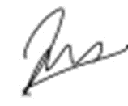______________
NINA SALINA BINTI SUZUKI
2022971209

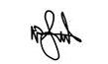
______________
NUR SAKINAH BINTI JAMIRAN
2022777155
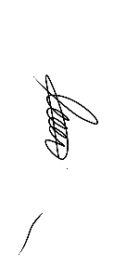
____________________
NUR FADHILAH BINTI ARIFIN
2022764227


____________________
NURUL JANNAH BINTI MOHD ROSNI
2022128721

TABLE OF CONTENT
NO. | CONTENT | PAGES
Acknowledgment |  | I
 | LIBRARY MANAGEMENT SYSTEM (iLIBS)
1.0 | Flow | 1
2.0 | User  2.1 main.py  2.2 userormembership.py  2.3 loginmember.py  2.4 forgotpassmember.py  2.5 userwithmembership.py  2.6 payment10.py  2.7 librarymember.py | 2  2  5  7  12  15  22  25
3.0 | Staff  3.1 loginstaff.py  3.2 forgotpassstaff.py  3.3 librarystaff.py  3.4 fine_system3.py  3.5 displaymembers.py | 33  33  37  40  55  59
4.0 | ICT Department  4.1 loginict.py  4.2 ict.py  4.3 staffregistration.py  4.4 liststaff.py | 67  67  71  79  86
5.0 | Databases  5.1 database.db  5.2 fine_system.db  5.3 bank.db | 94  95  100  101

LIBRARY MANAGEMENT SYSTEM (iLIBS)

1.0 Flow
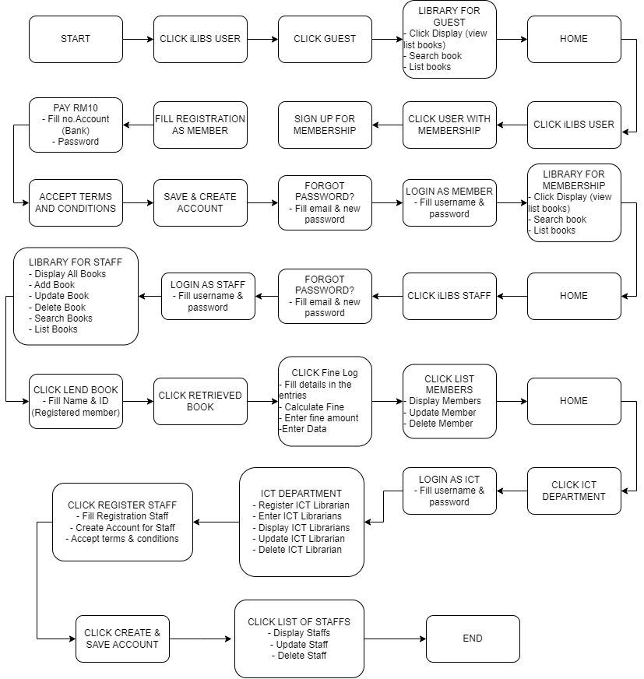

2.0 User
2.1 main.py
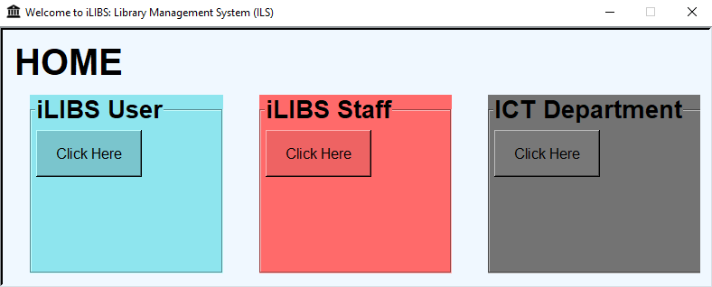

import tkinter as tk

def loginict():
window.destroy()
import loginict

def loginuser():
window.destroy()
import userormembership

def loginstaff():
window.destroy()
import loginstaff # Import the desired module

# Main Window
window = tk.Tk()
window.title("Welcome to iLIBS: Library Management System (ILS)")
window.geometry("790x290")
window.iconbitmap("icons/library.ico")
window.resizable(False, False)
window.configure(padx=10, pady=10, bg="#F0F8FF", relief='sunken', borderwidth=4)

# Set the window size
window_width = 790
window_height = 290

# Get the screen dimensions
screen_width = window.winfo_screenwidth()
screen_height = window.winfo_screenheight()

# Calculate the coordinates to center the window
x = (screen_width - window_width) // 2
y = (screen_height - window_height) // 2

# Set the window position
window.geometry(f"{window_width}x{window_height}+{x}+{y}")

# Main Frame
frame = tk.Frame(window, bg="#F0F8FF")
frame.pack()

lbl_home = tk.Label(frame, text="HOME", font=("Arial", 30, "bold"), bg="#F0F8FF")
lbl_home.grid(row=0,column=0, sticky="W")

# User frame
user_frame = tk.LabelFrame(frame, text="iLIBS User", font=("Arial", 20, "bold"), bg="#8EE5EE")
user_frame.grid(row=1, column=0, padx=20, pady=10, ipadx=30, ipady=50, sticky="news")

user_button = tk.Button(user_frame, text="Click Here", font=("bold"), bg="#7AC5CD", command=loginuser)
user_button.grid(row=0, column=0, ipadx=15, ipady=10)

for widget in user_frame.winfo_children():
widget.grid_configure(padx=5, pady=5)

# Staff Frame
staff_frame = tk.LabelFrame(frame, text="iLIBS Staff", font=("Arial", 20, "bold"), bg="#FF6A6A")
staff_frame.grid(row=1, column=1, padx=20, pady=10, ipadx=30, ipady=50, sticky="news")

staff_button = tk.Button(staff_frame, text="Click Here", font=("bold"), bg="#EE6363", command=loginstaff)
staff_button.grid(row=0, column=0, ipadx=15, ipady=10)

for widget in staff_frame.winfo_children():
widget.grid_configure(padx=5, pady=5)

ict_frame = tk.LabelFrame(frame, text="ICT Department", font=("Arial", 20, "bold"), bg="gray45")
ict_frame.grid(row=1,column=2, padx=20, pady=10, ipadx=30, ipady=50, sticky="news")

ict_button = tk.Button(ict_frame, text="Click Here", font=("bold"), bg="gray47", command=loginict)
ict_button.grid(row=0, column=0, ipadx=15, ipady=10)

for widget in ict_frame.winfo_children():
widget.grid_configure(padx=5, pady=5)

# Start the Tkinter event loop
window.mainloop()

2.2 userormembership.py
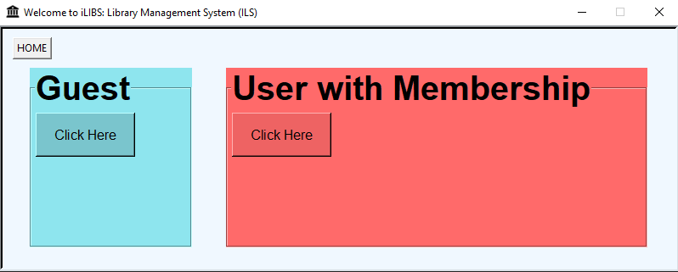
import tkinter as tk

def home():
window.destroy()
import main

def user():
window.destroy()
import librarymember

def member():
window.destroy()
import loginmember

# Main Window
window = tk.Tk()
window.title("Welcome to iLIBS: Library Management System (ILS)")
window.geometry("800x290")
window.iconbitmap("icons/library.ico")
window.resizable(False, False)
window.configure(padx=10, pady=10, bg="#F0F8FF", relief='sunken', borderwidth=4)

# Set the window size
window_width = 800
window_height = 290

# Get the screen dimensions
screen_width = window.winfo_screenwidth()
screen_height = window.winfo_screenheight()

# Calculate the coordinates to center the window
x = (screen_width - window_width) // 2
y = (screen_height - window_height) // 2

# Set the window position
window.geometry(f"{window_width}x{window_height}+{x}+{y}")

# Main Frame
frame = tk.Frame(window, bg="#F0F8FF")
frame.pack()

home_button = tk.Button(frame, text="HOME", command=home)
home_button.grid(row=0,column=0, sticky="W")

# User frame
user_frame = tk.LabelFrame(frame, text="Guest", font=("Arial", 30, "bold"), bg="#8EE5EE")
user_frame.grid(row=1, column=0, padx=20, pady=10, ipadx=30, ipady=50, sticky="news")

user_button = tk.Button(user_frame, text="Click Here", font=("bold"), bg="#7AC5CD", command=user)
user_button.grid(row=0, column=0, ipadx=15, ipady=10)

for widget in user_frame.winfo_children():
widget.grid_configure(padx=5, pady=5)

# Staff Frame
membership_frame = tk.LabelFrame(frame, text="User with Membership", font=("Arial", 30, "bold"), bg="#FF6A6A")
membership_frame.grid(row=1, column=1, padx=20, pady=10, ipadx=30, ipady=50, sticky="news")

membership_button = tk.Button(membership_frame, text="Click Here", font=("bold"), bg="#EE6363", command=member)
membership_button.grid(row=0, column=0, ipadx=15, ipady=10)

for widget in membership_frame.winfo_children():
widget.grid_configure(padx=5, pady=5)

# Start the Tkinter event loop
window.mainloop()

2.3 loginmember.py
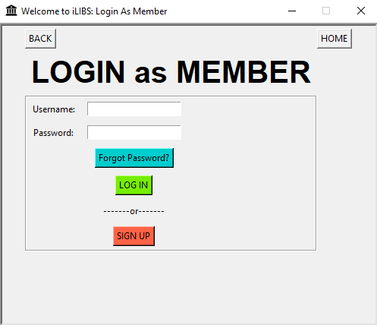
from tkinter import *
import tkinter
import tkinter as tk
from tkinter import messagebox
import sqlite3

def home():
window.destroy()
import main

def back():
window.destroy()
import userormembership

def forgot():
window.destroy()
import forgotpassmember

def login_success():
messagebox.showinfo("Login Successful", "Welcome, User!")
entry_username.delete(0, tk.END)
entry_password.delete(0, tk.END)
window.destroy()
import librarymember
# Import 'loginuser' module if required, but consider importing at the beginning of the script

def login():
# Connect to the database
conn = sqlite3.connect('database.db')
cursor = conn.cursor()

user = entry_username.get()
code = entry_password.get()

# Query the database for the username and password
query = "SELECT * FROM members WHERE member_user = ? AND member_pass = ?"
cursor.execute(query, (user, code))
result = cursor.fetchone()

if result is not None:
# User credentials are valid
login_success()

else:
# Invalid username or password
messagebox.showerror("Login Failed", "Invalid username or password")
entry_username.delete(0, tk.END)
entry_password.delete(0, tk.END)
prompt_try_again()

# Close the database connection
conn.close()

def prompt_try_again():
result = messagebox.askretrycancel("Try Again", "Do you want to try again?")
if result:
entry_username.focus_set() # Set focus back to username entry field
else:
window.destroy() # Close the login window

def reg():
window.destroy()
import userwithmembership

# Create the main window
window = tk.Tk()
window.title("Welcome to iLIBS: Login As Member")
window.iconbitmap("icons/library.ico")
window.geometry("500x400")
window.resizable(False,False)
window.configure(relief='sunken', borderwidth=4)

# Set the window size
window_width = 500
window_height = 400

# Get the screen dimensions
screen_width = window.winfo_screenwidth()
screen_height = window.winfo_screenheight()

# Calculate the coordinates to center the window
x = (screen_width - window_width) // 2
y = (screen_height - window_height) // 2

# Set the window position
window.geometry(f"{window_width}x{window_height}+{x}+{y}")

frame = tkinter.Frame(window,bg="",relief='sunken',borderwidth=4)
frame.pack()

home_button = tk.Button(frame, text="HOME", command=home)
home_button.grid(row=0,column=1, sticky="W")

back_button = tk.Button(frame, text="BACK", command=back)
back_button.grid(row=0,column=0, sticky="W")

login_label = tkinter.Label(frame, text="LOGIN as MEMBER", font=("Arial", 30, "bold"))
login_label.grid(row=1,column=0, padx=5,pady=5)

login_frame = tkinter.LabelFrame(frame)
login_frame.grid(row=2,column=0, sticky="news")

lbl_username = tkinter.Label(login_frame, text="Username: ")
lbl_username.grid(row=0,column=0)

entry_username = tkinter.Entry(login_frame, width=20)
entry_username.grid(row=0,column=1)

lbl_password = tkinter.Label(login_frame, text="Password: ")
lbl_password.grid(row=1,column=0)

entry_password = tkinter.Entry(login_frame, show="*", width=20)
entry_password.grid(row=1,column=1)

forgot_button = tk.Button(login_frame, text="Forgot Password?",bg="cyan3", command=forgot)
forgot_button.grid(row=2, column=1)

login_button = tkinter.Button(login_frame, text="LOG IN", bg="#76EE00", command=login)
login_button.grid(row=3,column=1)

lbl_or = tkinter.Label(login_frame, text="-------or-------")
lbl_or.grid(row=4,column=1)

signup_button = tkinter.Button(login_frame, text="SIGN UP", bg="tomato1", command=reg)
signup_button.grid(row=5,column=1)

for widget in login_frame.winfo_children():
widget.grid_configure(padx=5, pady=5)

# Start the main event loop
window.mainloop()

2.4 forgotpassmember.py
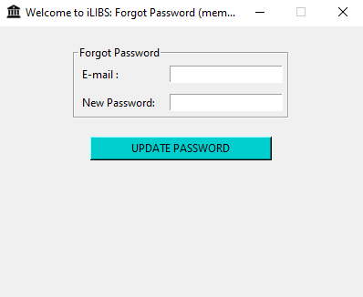
import tkinter as tk
from tkinter import messagebox
import sqlite3

def update_password():
# Retrieve the email and new password from the entry fields
email = entry_account.get()
new_password = entry_pass.get()

# Connect to the database
conn = sqlite3.connect('database.db')
cursor = conn.cursor()

# Update the password for the provided email
update_query = "UPDATE members SET member_pass = ? WHERE member_email = ?"
cursor.execute(update_query, (new_password, email))
conn.commit()

# Close the database connection
conn.close()

# Show appropriate message box based on the password update success
if cursor.rowcount > 0:
messagebox.showinfo("Password Updated", "Password updated successfully.")
window.destroy()
import loginmember
else:
messagebox.showinfo("Password Update Failed", "No matching email found.")
# Main Window
window = tk.Tk()
window.title("Welcome to iLIBS: Forgot Password (member)")
window.geometry("400x300")
window.iconbitmap("icons/library.ico")
window.resizable(False, False)

# Set the window size
window_width = 400
window_height = 300

# Get the screen dimensions
screen_width = window.winfo_screenwidth()
screen_height = window.winfo_screenheight()

# Calculate the coordinates to center the window
x = (screen_width - window_width) // 2
y = (screen_height - window_height) // 2

# Set the window position
window.geometry(f"{window_width}x{window_height}+{x}+{y}")

frame = tk.Frame(window)
frame.pack()

forgot_frame = tk.LabelFrame(frame, text="Forgot Password")
forgot_frame.grid(row=1, column=0, sticky="news", padx=20, pady=20)

lbl_noacc = tk.Label(forgot_frame, text="E-mail : ")
lbl_noacc.grid(row=0, column=0, sticky="W")

entry_account = tk.Entry(forgot_frame)
entry_account.grid(row=0, column=1, sticky="W")

lbl_pass = tk.Label(forgot_frame, text="New Password: ")
lbl_pass.grid(row=1, column=0, sticky="W")

entry_pass = tk.Entry(forgot_frame)
entry_pass.grid(row=1, column=1, sticky="W")

pay_button = tk.Button(frame, text="UPDATE PASSWORD", bg="cyan3", command=update_password)
pay_button.grid(row=2, column=0, ipadx=40, sticky="N")

for widget in forgot_frame.winfo_children():
widget.grid_configure(padx=5, pady=5)

window.mainloop()

2.5 userwithmembership.py
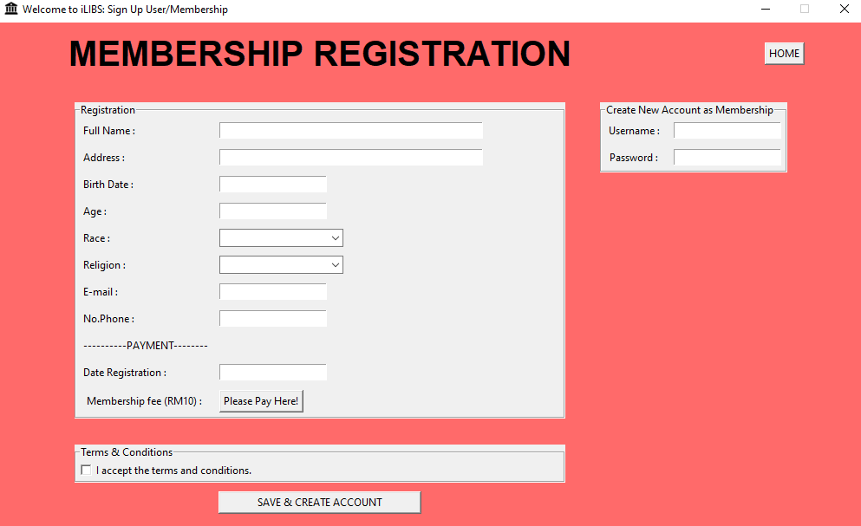
import tkinter
import tkinter as tk
from tkinter import ttk, messagebox
import sqlite3

# DEFINITIONS
def back():
window.destroy()
import loginmember

def pay():
import payment10

def create_table():
conn = sqlite3.connect("database.db")
cursor = conn.cursor()
cursor.execute("CREATE TABLE IF NOT EXISTS members (id INTEGER PRIMARY KEY AUTOINCREMENT, member_name TEXT, member_address TEXT, member_birth TEXT, member_age INTEGER, member_race TEXT, member_religion TEXT, member_email TEXT, member_phone TEXT, member_user TEXT, member_date TEXT, member_pass TEXT)")
conn.commit()
conn.close()

def insert_data():
accepted = accept_var.get()

if accepted=="Accepted":
member_name = entry_fullname.get()
member_address = entry_address.get()
member_birth = entry_birth.get()
member_age = entry_age.get()
member_race = entry_race.get()
member_religion = entry_religion.get()
member_email = entry_email.get()
member_phone = entry_phone.get()
member_date = entry_date.get()
member_user = entry_username.get()
member_pass = entry_password.get()

if member_name and member_address and member_birth and member_age and member_race and member_religion and member_email and member_phone and member_date and member_user and member_pass:

conn = sqlite3.connect("database.db")
cursor = conn.cursor()
cursor.execute("INSERT INTO members (member_name,member_address,member_birth,member_age,member_race,member_religion,member_email,member_phone,member_date,member_user,member_pass) VALUES(?,?,?,?,?,?,?,?,?,?,?)",(member_name,member_address,member_birth,member_age,member_race,member_religion,member_email,member_phone,member_date,member_user,member_pass))
conn.commit()
conn.close()
messagebox.showinfo("Success","Successfully added to database",icon='info')

entry_fullname.delete(0,tk.END)
entry_address.delete(0,tk.END)
entry_birth.delete(0,tk.END)
entry_age.delete(0,tk.END)
entry_race.delete(0,tk.END)
entry_religion.delete(0,tk.END)
entry_email.delete(0,tk.END)
entry_phone.delete(0,tk.END)
entry_date.delete(0,tk.END)
entry_username.delete(0,tk.END)
entry_password.delete(0,tk.END)
else:
tkinter.messagebox.showwarning(title="Error", message="Fields cannot be empty", icon="warning")
else:
tkinter.messagebox.showwarning(title= "Error", message="You have not accepted the terms", icon="warning")

# Main Window
window = tk.Tk()
window.title("Welcome to iLIBS: Sign Up User/Membership")
window.geometry("1000x600")
window.iconbitmap("icons/library.ico")
window.resizable(False,False)
window.configure(bg="#FF6A6A")

# Set the window size
window_width = 1000
window_height = 600

# Get the screen dimensions
screen_width = window.winfo_screenwidth()
screen_height = window.winfo_screenheight()

# Calculate the coordinates to center the window
x = (screen_width - window_width) // 2
y = (screen_height - window_height) // 2

# Set the window position
window.geometry(f"{window_width}x{window_height}+{x}+{y}")

# Main Frame
frame = tkinter.Frame(window, bg="#FF6A6A")
frame.pack()

home_buttom = tkinter.Button(frame, text="HOME",command=back)
home_buttom.grid(row=0,column=1,sticky="E")

lbl1 = tkinter.Label(frame, text="MEMBERSHIP REGISTRATION", font=("Arial", 30, "bold"), bg="#FF6A6A")
lbl1.grid(row=0,column=0,padx=10,pady=10)

# Registration/Payment Frame
membership_frame = tkinter.LabelFrame(frame, text="Registration")
membership_frame.grid(row=1,column=0, sticky="news", padx=20,pady=20)

lbl_fullname = tkinter.Label(membership_frame, text="Full Name : ")
lbl_fullname.grid(row=0,column=0, sticky="W")

entry_fullname = tkinter.Entry(membership_frame, width=50)
entry_fullname.grid(row=0,column=1, sticky="W")

lbl_address = tkinter.Label(membership_frame, text="Address : ")
lbl_address.grid(row=1,column=0,sticky="W")

entry_address = tkinter.Entry(membership_frame, width=50)
entry_address.grid(row=1,column=1,sticky="W")

lbl_birthdate = tkinter.Label(membership_frame, text="Birth Date : ")
lbl_birthdate.grid(row=2,column=0,sticky="W")

entry_birth = tkinter.Entry(membership_frame)
entry_birth.grid(row=2,column=1,sticky="W")

lbl_age = tkinter.Label(membership_frame, text="Age : ")
lbl_age.grid(row=3,column=0,sticky="W")

entry_age = tkinter.Entry(membership_frame)
entry_age.grid(row=3,column=1, sticky="W")

lbl_race = tkinter.Label(membership_frame, text="Race : ")
lbl_race.grid(row=4,column=0, sticky="W")

entry_race = ttk.Combobox(membership_frame, values=["Malay","Chinese","Indian","Bumiputera","Other"])
entry_race.grid(row=4,column=1, sticky="W")

lbl_religion = tkinter.Label(membership_frame, text="Religion : ")
lbl_religion.grid(row=5,column=0,sticky="w")

entry_religion = ttk.Combobox(membership_frame, values=["Islam","Christian","Buddha","Hindu","Other"])
entry_religion.grid(row=5,column=1, sticky="W")

lbl_email = tkinter.Label(membership_frame, text="E-mail : ")
lbl_email.grid(row=6,column=0,sticky="w")

entry_email = tkinter.Entry(membership_frame, width=20)
entry_email.grid(row=6,column=1,sticky="w")

lbl_phone = tkinter.Label(membership_frame, text="No.Phone : ")
lbl_phone.grid(row=7,column=0,sticky="w")

entry_phone = tkinter.Entry(membership_frame)
entry_phone.grid(row=7,column=1,sticky="w")

lbl_pay = tkinter.Label(membership_frame, text="----------PAYMENT--------")
lbl_pay.grid(row=8,column=0,sticky="W")

lbl_date_registration = tkinter.Label(membership_frame, text="Date Registration : ")
lbl_date_registration.grid(row=9,column=0, sticky="W")

entry_date = tkinter.Entry(membership_frame)
entry_date.grid(row=9,column=1, sticky="W")

lbl_fee = tkinter.Label(membership_frame, text="Membership fee (RM10) : ")
lbl_fee.grid(row=10,column=0)

lbl_payment = tkinter.Button(membership_frame, text="Please Pay Here!", command=pay)
lbl_payment.grid(row=10,column=1, sticky="W")

for widget in membership_frame.winfo_children():
widget.grid_configure(padx=5, pady=5)

# Account Frame
account_frame = tkinter.LabelFrame(frame, text="Create New Account as Membership")
account_frame.grid(row=1,column=1, padx=20,pady=20, sticky="NW")

lbl_username = tkinter.Label(account_frame, text="Username : ")
lbl_username.grid(row=0,column=0,sticky="W")

entry_username = tkinter.Entry(account_frame)
entry_username.grid(row=0,column=1,sticky="W")

lbl_password = tkinter.Label(account_frame, text="Password : ")
lbl_password.grid(row=1,column=0)

entry_password = tkinter.Entry(account_frame)
entry_password.grid(row=1,column=1)

for widget in account_frame.winfo_children():
widget.grid_configure(padx=5, pady=5)

# ACCEPT TERMS FRAME
terms_frame = tkinter.LabelFrame(frame, text="Terms & Conditions")
terms_frame.grid(row=2, column=0, sticky="news", padx=20, pady=10)

accept_var = tkinter.StringVar(value="Not Accepted")
terms_check = tkinter.Checkbutton(terms_frame, text="I accept the terms and conditions.", variable=accept_var, onvalue="Accepted", offvalue="Not Accepted")
terms_check.grid(row=0, column=0)

save_button = tkinter.Button(frame, text="SAVE & CREATE ACCOUNT", command=insert_data)
save_button.grid(row=3,column=0,ipadx=40, sticky="N")

create_table()

window.mainloop()

2.6 payment10.py
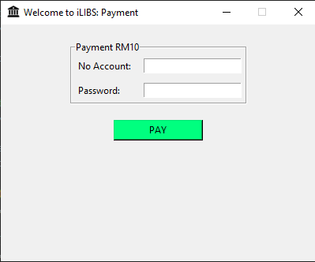
import tkinter as tk
from tkinter import messagebox
import sqlite3

def pay():
# Connect to the database
conn = sqlite3.connect('bank.db')
cursor = conn.cursor()

# Retrieve the account number and password from the entry fields
account_number = entry_account.get()
password = entry_pass.get()

# Retrieve the current fund balance
query = "SELECT fund FROM list_acc WHERE account_number = ? AND pass_acc = ?"
cursor.execute(query, (account_number, password))
current_fund = cursor.fetchone()

if current_fund is not None:
current_fund = current_fund[0]
if current_fund >= 10:
# Deduct RM10 from the user's fund
new_fund = current_fund - 10

# Update the fund balance in the database
update_query = "UPDATE list_acc SET fund = ? WHERE account_number = ? AND pass_acc = ?"
cursor.execute(update_query, (new_fund, account_number, password))
conn.commit()

messagebox.showinfo("Payment Successful", "Deducted RM10 from the user's fund.")
entry_account.delete(0, tk.END)
entry_pass.delete(0, tk.END)
window.destroy()
else:
messagebox.showerror("Payment Failed", "Insufficient funds.")
else:
messagebox.showerror("Payment Failed", "Invalid account number or password.")

# Close the database connection
conn.close()

# Main Window
window = tk.Tk()
window.title("Welcome to iLIBS: Payment")
window.geometry("400x300")
window.iconbitmap("icons/library.ico")
window.resizable(False, False)

# Set the window size
window_width = 400
window_height = 300

# Get the screen dimensions
screen_width = window.winfo_screenwidth()
screen_height = window.winfo_screenheight()

# Calculate the coordinates to center the window
x = (screen_width - window_width) // 2
y = (screen_height - window_height) // 2

# Set the window position
window.geometry(f"{window_width}x{window_height}+{x}+{y}")

frame = tk.Frame(window)
frame.pack()

payment_frame = tk.LabelFrame(frame, text="Payment RM10")
payment_frame.grid(row=1, column=0, sticky="news", padx=20, pady=20)

lbl_noacc = tk.Label(payment_frame, text="No Account: ")
lbl_noacc.grid(row=0, column=0, sticky="W")

entry_account = tk.Entry(payment_frame)
entry_account.grid(row=0, column=1, sticky="W")

lbl_pass = tk.Label(payment_frame, text="Password: ")
lbl_pass.grid(row=1, column=0, sticky="W")

entry_pass = tk.Entry(payment_frame, show="*")
entry_pass.grid(row=1, column=1, sticky="W")

pay_button = tk.Button(frame, text="PAY", bg="springgreen",command=pay)
pay_button.grid(row=2, column=0, ipadx=40, sticky="N")

for widget in payment_frame.winfo_children():
widget.grid_configure(padx=5, pady=5)

window.mainloop()

2.7 librarymember.py
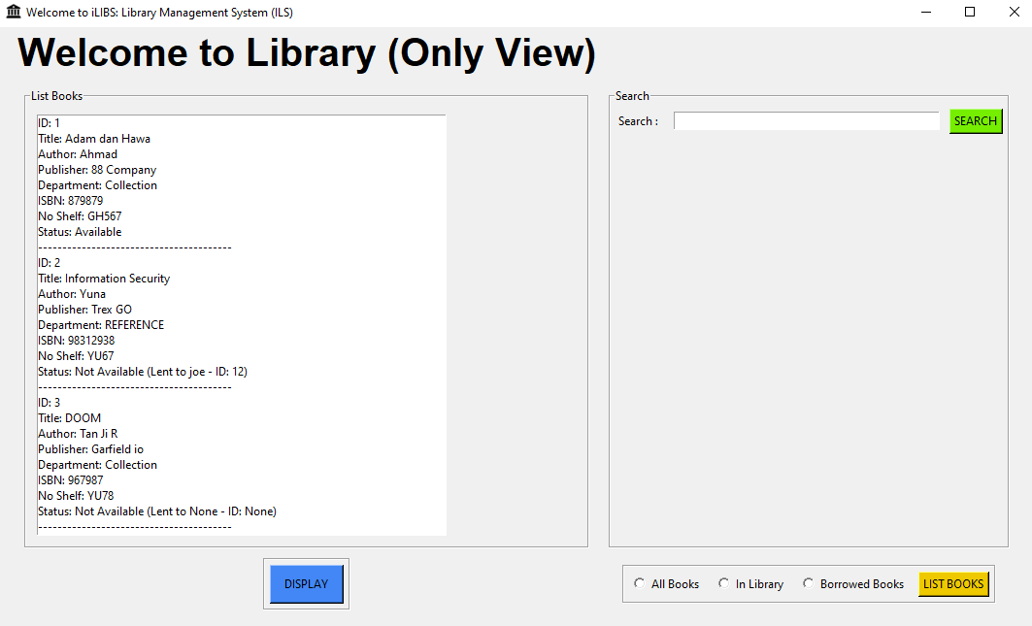
from tkinter import *
import tkinter
import tkinter as tk
from tkinter import ttk, messagebox
import sqlite3

def create_table():
conn = sqlite3.connect("database.db")
cursor = conn.cursor()
cursor.execute("CREATE TABLE IF NOT EXISTS books (id INTEGER PRIMARY KEY AUTOINCREMENT, title TEXT, author TEXT, publisher TEXT, department TEXT, isbn TEXT, noshelf TEXT, status INTEGER, member_name TEXT, member_id INTEGER)")
conn.commit()
conn.close()

def display_data():
conn = sqlite3.connect("database.db")
cursor = conn.cursor()
cursor.execute("SELECT id, title, author, publisher, department, isbn, noshelf, status, member_name, member_id FROM books")
rows = cursor.fetchall()
conn.close()

listbook_display.delete(0, tk.END)
for row in rows:
id_book, title_book, author_book, publisher_book, department_book, isbn_book, noshelf_book, status_book, member_name, member_id = row
display_text = f"ID: {id_book}"
listbook_display.insert(tk.END, display_text)
display_text = f"Title: {title_book}"
listbook_display.insert(tk.END, display_text)
display_text = f"Author: {author_book}"
listbook_display.insert(tk.END, display_text)
display_text = f"Publisher: {publisher_book}"
listbook_display.insert(tk.END, display_text)
display_text = f"Department: {department_book}"
listbook_display.insert(tk.END, display_text)
display_text = f"ISBN: {isbn_book}"
listbook_display.insert(tk.END, display_text)
display_text = f"No Shelf: {noshelf_book}"
listbook_display.insert(tk.END, display_text)

if status_book == 1:
status_text = "Status: Available"
else:
status_text = f"Status: Not Available (Lent to {member_name} - ID: {member_id})"

listbook_display.insert(tk.END, status_text)
listbook_display.insert(tk.END, "-" * 40)

def search_data():
search_query = entry_search.get()

conn = sqlite3.connect("database.db")
cursor = conn.cursor()
cursor.execute("SELECT id, title, author, publisher, department, isbn, noshelf, status FROM books WHERE title LIKE ? OR author LIKE ? OR publisher LIKE ? OR department LIKE ? OR isbn LIKE ? OR noshelf LIKE ?",
(f"%{search_query}%", f"%{search_query}%", f"%{search_query}%", f"%{search_query}%", f"%{search_query}%", f"%{search_query}%"))
rows = cursor.fetchall()
conn.close()

listbook_display.delete(0, tk.END)
for row in rows:
id_book, title_book, author_book, publisher_book, department_book, isbn_book, noshelf_book, status_book = row
display_text = f"ID: {id_book}"
listbook_display.insert(tk.END, display_text)
display_text = f"Title: {title_book}"
listbook_display.insert(tk.END, display_text)
display_text = f"Author: {author_book}"
listbook_display.insert(tk.END, display_text)
display_text = f"Publisher: {publisher_book}"
listbook_display.insert(tk.END, display_text)
display_text = f"Department: {department_book}"
listbook_display.insert(tk.END, display_text)
display_text = f"ISBN: {isbn_book}"
listbook_display.insert(tk.END, display_text)
display_text = f"No Shelf: {noshelf_book}"
listbook_display.insert(tk.END, display_text)
status_text = "Status: Available" if status_book == 1 else "Status: Not Available"
listbook_display.insert(tk.END, status_text)
listbook_display.insert(tk.END, "")

def list_book():
selected_value = rb1_var.get()
if selected_value == 1: # All Books
display_data()
elif selected_value == 2: # In Library (Available Books)
conn = sqlite3.connect("database.db")
cursor = conn.cursor()
cursor.execute("SELECT id, title, author, publisher, department, isbn, noshelf, status FROM books WHERE status = 1")
rows = cursor.fetchall()
conn.close()
listbook_display.delete(0, tk.END)
if rows:
for row in rows:
id_book, title_book, author_book, publisher_book, department_book, isbn_book, noshelf_book, status_book = row
display_text = f"ID: {id_book}"
listbook_display.insert(tk.END, display_text)
display_text = f"Title: {title_book}"
listbook_display.insert(tk.END, display_text)
display_text = f"Author: {author_book}"
listbook_display.insert(tk.END, display_text)
display_text = f"Publisher: {publisher_book}"
listbook_display.insert(tk.END, display_text)
display_text = f"Department: {department_book}"
listbook_display.insert(tk.END, display_text)
display_text = f"ISBN: {isbn_book}"
listbook_display.insert(tk.END, display_text)
display_text = f"No Shelf: {noshelf_book}"
listbook_display.insert(tk.END, display_text)
status_text = "Status: Available"
listbook_display.insert(tk.END, status_text)
listbook_display.insert(tk.END, "")
else:
listbook_display.insert(tk.END, "No available books.")
elif selected_value == 3: # Borrowed Books (Not Available Books)
conn = sqlite3.connect("database.db")
cursor = conn.cursor()
cursor.execute("SELECT id, title, author, publisher, department, isbn, noshelf, status FROM books WHERE status = 0")
rows = cursor.fetchall()
conn.close()
listbook_display.delete(0, tk.END)
if rows:
for row in rows:
id_book, title_book, author_book, publisher_book, department_book, isbn_book, noshelf_book, status_book = row
display_text = f"ID: {id_book}"
listbook_display.insert(tk.END, display_text)
display_text = f"Title: {title_book}"
listbook_display.insert(tk.END, display_text)
display_text = f"Author: {author_book}"
listbook_display.insert(tk.END, display_text)
display_text = f"Publisher: {publisher_book}"
listbook_display.insert(tk.END, display_text)
display_text = f"Department: {department_book}"
listbook_display.insert(tk.END, display_text)
display_text = f"ISBN: {isbn_book}"
listbook_display.insert(tk.END, display_text)
display_text = f"No Shelf: {noshelf_book}"
listbook_display.insert(tk.END, display_text)
status_text = "Status: Not Available"
listbook_display.insert(tk.END, status_text)
listbook_display.insert(tk.END, "")
else:
listbook_display.insert(tk.END, "No borrowed books.")

# Main Window
window = tk.Tk()
window.title("Welcome to iLIBS: Library Management System (ILS)")
window.geometry("1070x700")
window.iconbitmap("icons/library.ico")

# Set the window size
window_width = 1070
window_height =700

# Get the screen dimensions
screen_width = window.winfo_screenwidth()
screen_height = window.winfo_screenheight()

# Calculate the coordinates to center the window
x = (screen_width - window_width) // 2
y = (screen_height - window_height) // 2

# Set the window position
window.geometry(f"{window_width}x{window_height}+{x}+{y}")

frame = tk.Frame(window, bg="")
frame.pack()

# frames
top_frame = tkinter.LabelFrame(frame, text="Tool Bars")
top_frame.grid(row=0,column=0,sticky="news")

lbl_userlibrary = tkinter.Label(frame, text="Welcome to Library (Only View)", font=("Arial", 30, "bold"))
lbl_userlibrary.grid(row=0,column=0)

display_frame = tkinter.LabelFrame(frame, text="List Books")
display_frame.grid(row=1,column=0, padx=10, pady=10, sticky="news")

# frame search
search_frame = tkinter.LabelFrame(frame, text="Search")
search_frame.grid(row=1,column=1,padx=10, pady=10, sticky="news")

lbl_search = tkinter.Label(search_frame, text="Search : ")
lbl_search.grid(row=0,column=0,padx=10, pady=1,)

entry_search = tkinter.Entry(search_frame, width=45)
entry_search.grid(row=0,column=1)

search_button = tkinter.Button(search_frame, text="SEARCH",command=search_data, bg="#76EE00", fg="black")
search_button.grid(row=0,column=2)

for widget in search_frame.winfo_children():
widget.grid_configure(padx=5, pady=5)

crudframe = tkinter.LabelFrame(frame)
crudframe.grid(row=3,column=0)

display_button = tkinter.Button(crudframe, text="DISPLAY",command=display_data, bg="#4287f5", fg="black")
display_button.grid(row=0,column=0,ipadx=10,ipady=7,padx=5,pady=5)

# Create list_bar LabelFrame
list_bar = tkinter.LabelFrame(frame)
list_bar.grid(row=3, column=1, padx=5, pady=5)

# Create Radiobuttons
rb1_var = tkinter.IntVar()
rb1 = tkinter.Radiobutton(list_bar, text="All Books", value=1, variable=rb1_var)
rb2 = tkinter.Radiobutton(list_bar, text="In Library", value=2, variable=rb1_var)
rb3 = tkinter.Radiobutton(list_bar, text="Borrowed Books", value=3, variable=rb1_var)

rb1.grid(row=0, column=0, padx=5, pady=5)
rb2.grid(row=0, column=1, padx=5, pady=5)
rb3.grid(row=0, column=2, padx=5, pady=5)

# Create List Books button
list_button = tkinter.Button(list_bar, text="LIST BOOKS", command=list_book, bg="#EEC900", fg="black")
list_button.grid(row=0, column=3, padx=5, pady=5)

# Configure padding for all widgets inside list_bar
for widget in list_bar.winfo_children():
widget.grid_configure(padx=5, pady=5)

# displays
listbook_display = tkinter.Listbox(display_frame, width=70, height=27)
listbook_display.grid(row=0,column=0, padx=10, pady=10, sticky="news")

create_table()

window.mainloop()

3.0 Staff
3.1 loginstaff.py
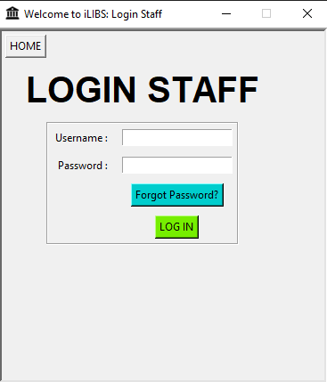
from tkinter import *
import tkinter
import tkinter as tk
from tkinter import messagebox
import sqlite3

def forgot():
window.destroy()
import forgotpassstaff

def home():
window.destroy()
import main

def login_success():
messagebox.showinfo("Login Successful", "Welcome, Staff!")
entry_username.delete(0, END)
entry_password.delete(0, END)
window.destroy() # Close the login window
import librarystaff

def login():
conn = sqlite3.connect('database.db')
cursor = conn.cursor()

user = entry_username.get()
code = entry_password.get()

query = "SELECT * FROM staff WHERE staff_user = ? AND staff_pass = ?"
cursor.execute(query, (user, code))
result = cursor.fetchone()

if result is not None:
# User credentials are valid
login_success()

else:
# Invalid username or password
messagebox.showerror("Login Failed", "Invalid username or password")
entry_username.delete(0, tk.END)
entry_password.delete(0, tk.END)
prompt_try_again()

conn.close()

def prompt_try_again():
result = messagebox.askretrycancel("Try Again", "Do you want to try again?")
if result == True:
entry_password.focus_set() # Set focus back to username entry field
else:
window.destroy() # Close the login window

# Create the main window
window = tk.Tk()
window.title("Welcome to iLIBS: Login Staff")
window.iconbitmap("icons/library.ico")
window.geometry("370x400")
window.resizable(False,False)
window.configure(relief='sunken', borderwidth=4)

# Set the window size
window_width = 370
window_height = 400

# Get the screen dimensions
screen_width = window.winfo_screenwidth()
screen_height = window.winfo_screenheight()

# Calculate the coordinates to center the window
x = (screen_width - window_width) // 2
y = (screen_height - window_height) // 2

# Set the window position
window.geometry(f"{window_width}x{window_height}+{x}+{y}")

frame = tkinter.Frame(window,bg="",relief='sunken',borderwidth=4)
frame.grid()

home_button = tk.Button(frame, text="HOME", command=home)
home_button.grid(row=0,column=0, sticky="W")

login_label = tkinter.Label(frame, text="LOGIN STAFF", font=("Arial", 30, "bold"))
login_label.grid(row=1,column=0, padx=20,pady=10)

login_frame = tkinter.LabelFrame(frame)
login_frame.grid(row=2,column=0)

lbl_username = tkinter.Label(login_frame, text="Username : ")
lbl_username.grid(row=0,column=0)

entry_username = tkinter.Entry(login_frame, width=20)
entry_username.grid(row=0,column=1)

lbl_password = Label(login_frame, text="Password :")
lbl_password.grid(row=1,column=0,padx=5,pady=2)
password = StringVar() # Create a StringVar for the password
entry_password = Entry(login_frame, show="*", textvariable=password)
entry_password.grid(row=1,column=1,padx=5,pady=2)

forgot_button = tk.Button(login_frame, text="Forgot Password?", bg="cyan3",command=forgot)
forgot_button.grid(row=2, column=1)

login_button = tkinter.Button(login_frame, text="LOG IN", command=login, bg="#76EE00", fg="black")
login_button.grid(row=3,column=1)

for widget in login_frame.winfo_children():
widget.grid_configure(padx=5, pady=5)

# Start the main event loop
window.mainloop()

3.2 forgotpassstaff.py
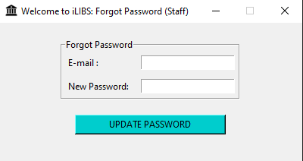
import tkinter as tk
from tkinter import messagebox
import sqlite3

def update_password():
# Retrieve the email and new password from the entry fields
email = entry_account.get()
new_password = entry_pass.get()

# Connect to the database
conn = sqlite3.connect('database.db')
cursor = conn.cursor()

# Update the password for the provided email
update_query = "UPDATE staff SET staff_pass = ? WHERE staff_email = ?"
cursor.execute(update_query, (new_password, email))
conn.commit()

# Close the database connection
conn.close()

# Show appropriate message box based on the password update success
if cursor.rowcount > 0:
messagebox.showinfo("Password Updated", "Password updated successfully.")
window.destroy()
import loginstaff
else:
messagebox.showinfo("Password Update Failed", "No matching email found.")
# Main Window
window = tk.Tk()
window.title("Welcome to iLIBS: Forgot Password (Staff)")
window.geometry("400x300")
window.iconbitmap("icons/library.ico")
window.resizable(False, False)

# Set the window size
window_width = 400
window_height = 300

# Get the screen dimensions
screen_width = window.winfo_screenwidth()
screen_height = window.winfo_screenheight()

# Calculate the coordinates to center the window
x = (screen_width - window_width) // 2
y = (screen_height - window_height) // 2

# Set the window position
window.geometry(f"{window_width}x{window_height}+{x}+{y}")

frame = tk.Frame(window)
frame.pack()

forgot_frame = tk.LabelFrame(frame, text="Forgot Password")
forgot_frame.grid(row=1, column=0, sticky="news", padx=20, pady=20)

lbl_noacc = tk.Label(forgot_frame, text="E-mail : ")
lbl_noacc.grid(row=0, column=0, sticky="W")

entry_account = tk.Entry(forgot_frame)
entry_account.grid(row=0, column=1, sticky="W")

lbl_pass = tk.Label(forgot_frame, text="New Password: ")
lbl_pass.grid(row=1, column=0, sticky="W")

entry_pass = tk.Entry(forgot_frame)
entry_pass.grid(row=1, column=1, sticky="W")

pay_button = tk.Button(frame, text="UPDATE PASSWORD", bg="cyan3", command=update_password)
pay_button.grid(row=2, column=0, ipadx=40, sticky="N")

for widget in forgot_frame.winfo_children():
widget.grid_configure(padx=5, pady=5)

window.mainloop()

3.3 librarystaff.py
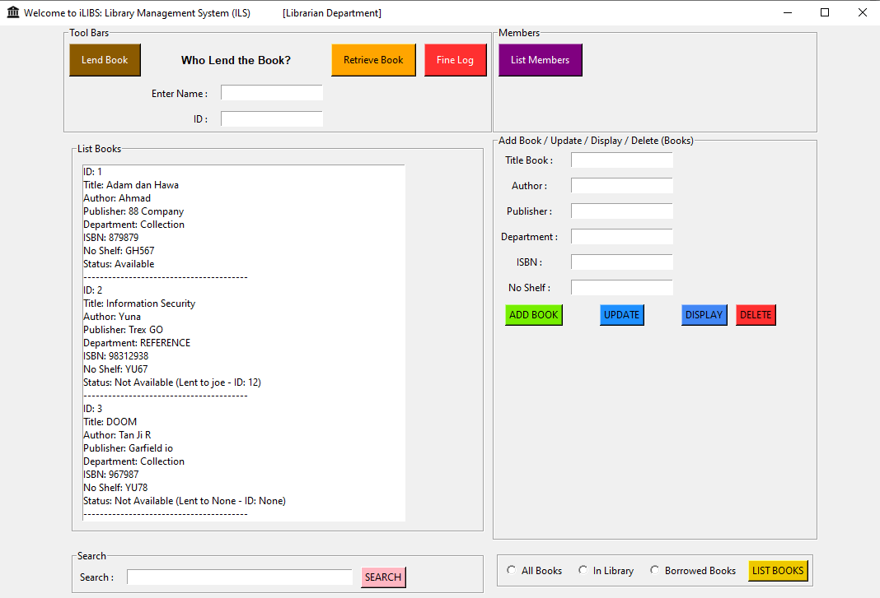
from tkinter import *
import tkinter
import tkinter as tk
from tkinter import ttk, messagebox
import sqlite3

def pay():
import fine_system3

def members():
import displaymembers

def create_table():
conn = sqlite3.connect("database.db")
cursor = conn.cursor()
cursor.execute("CREATE TABLE IF NOT EXISTS books (id INTEGER PRIMARY KEY AUTOINCREMENT, title TEXT, author TEXT, publisher TEXT, department TEXT, isbn TEXT, noshelf TEXT, status INTEGER, member_name TEXT, member_id INTEGER)")
conn.commit()
conn.close()

def lend_book():
selected_item = listbook_display.curselection()
if not selected_item:
return

selected_id = listbook_display.get(selected_item[0]).split(':')[1].strip()

conn = sqlite3.connect("database.db")
cursor = conn.cursor()
cursor.execute("SELECT status FROM books WHERE id=?", (selected_id,))
status = cursor.fetchone()

if status and status[0] == 1:
# Get member information
member_name = entry_member_name.get()
member_id = entry_member_id.get()

if member_name and member_id:
# Update book status and insert member information
cursor.execute("UPDATE books SET status=?, member_name=?, member_id=? WHERE id=?", (0, member_name, member_id, selected_id))
conn.commit()
messagebox.showinfo("Success", "Book successfully lent to member", icon='info')
display_data()
else:
messagebox.showwarning("Error", "Please enter member information")
else:
messagebox.showwarning("Error", "Book is not available")

conn.close()

def retrieve_book():
selected_item = listbook_display.curselection()
if not selected_item:
return

selected_id = listbook_display.get(selected_item[0]).split(':')[1].strip()

conn = sqlite3.connect("database.db")
cursor = conn.cursor()
cursor.execute("SELECT status FROM books WHERE id=?", (selected_id,))
status = cursor.fetchone()

if status and status[0] == 0:
cursor.execute("UPDATE books SET status=? WHERE id=?", (1, selected_id)) # Update status to 1 (book available)
conn.commit()
messagebox.showinfo("Success", "Book successfully retrieved", icon='info')
else:
messagebox.showwarning("Error", "Book is already available")

conn.close()
display_data()

def insert_data():
title_book = entry_titlebook.get()
author_book = entry_author.get()
publisher_book = entry_publisher.get()
department_book = entry_department.get()
isbn_book = entry_isbn.get()
noshelf_book = entry_noshelf.get()
status_book = 1 # Assuming a default status of 1 (book in the library)

if title_book and author_book and publisher_book and department_book and isbn_book and noshelf_book:
conn = sqlite3.connect("database.db")
cursor = conn.cursor()
cursor.execute("INSERT INTO books (title, author, publisher, department, isbn, noshelf, status) VALUES (?, ?, ?, ?, ?, ?, ?)",
(title_book, author_book, publisher_book, department_book, isbn_book, noshelf_book, status_book))
conn.commit()
conn.close()
messagebox.showinfo("Success", "Successfully added to database", icon='info')

entry_titlebook.delete(0, tk.END)
entry_author.delete(0, tk.END)
entry_publisher.delete(0, tk.END)
entry_department.delete(0, tk.END)
entry_isbn.delete(0, tk.END)
entry_noshelf.delete(0, tk.END)
else:
messagebox.showwarning(title="Error", message="Fields cannot be empty", icon="warning")

def display_data():
conn = sqlite3.connect("database.db")
cursor = conn.cursor()
cursor.execute("SELECT id, title, author, publisher, department, isbn, noshelf, status, member_name, member_id FROM books")
rows = cursor.fetchall()
conn.close()

listbook_display.delete(0, tk.END)
for row in rows:
id_book, title_book, author_book, publisher_book, department_book, isbn_book, noshelf_book, status_book, member_name, member_id = row
display_text = f"ID: {id_book}"
listbook_display.insert(tk.END, display_text)
display_text = f"Title: {title_book}"
listbook_display.insert(tk.END, display_text)
display_text = f"Author: {author_book}"
listbook_display.insert(tk.END, display_text)
display_text = f"Publisher: {publisher_book}"
listbook_display.insert(tk.END, display_text)
display_text = f"Department: {department_book}"
listbook_display.insert(tk.END, display_text)
display_text = f"ISBN: {isbn_book}"
listbook_display.insert(tk.END, display_text)
display_text = f"No Shelf: {noshelf_book}"
listbook_display.insert(tk.END, display_text)

if status_book == 1:
status_text = "Status: Available"
else:
status_text = f"Status: Not Available (Lent to {member_name} - ID: {member_id})"

listbook_display.insert(tk.END, status_text)
listbook_display.insert(tk.END, "-" * 40)

def update_data():
selected_item = listbook_display.curselection()

if not selected_item:
return

new_title = entry_titlebook.get()
new_author = entry_author.get()
new_publisher = entry_publisher.get()
new_department = entry_department.get()
new_isbn = entry_isbn.get()
new_noshelf = entry_noshelf.get()

selected_item_text = listbook_display.get(selected_item[0])
selected_item_id = selected_item_text.split(':')[1].strip()

conn = sqlite3.connect("database.db")
cursor = conn.cursor()
cursor.execute("UPDATE books SET title=?, author=?, publisher=?, department=?, isbn=?, noshelf=? WHERE id=?", (new_title, new_author, new_publisher, new_department, new_isbn, new_noshelf, selected_item_id))
conn.commit()
conn.close()

entry_titlebook.delete(0, tk.END)
entry_author.delete(0, tk.END)
entry_publisher.delete(0, tk.END)
entry_department.delete(0, tk.END)
entry_isbn.delete(0, tk.END)
entry_noshelf.delete(0, tk.END)

display_data()

def delete_data():
selected_item = listbook_display.curselection()
if not selected_item:
return

selected_id = listbook_display.get(selected_item).split(":")[1].strip()

conn = sqlite3.connect("database.db")
cursor = conn.cursor()
cursor.execute("DELETE FROM books WHERE id=?", (selected_id,))
conn.commit()
conn.close()

display_data()

def search_data():
search_query = entry_search.get()

conn = sqlite3.connect("database.db")
cursor = conn.cursor()
cursor.execute("SELECT id, title, author, publisher, department, isbn, noshelf, status FROM books WHERE title LIKE ? OR author LIKE ? OR publisher LIKE ? OR department LIKE ? OR isbn LIKE ? OR noshelf LIKE ?",
(f"%{search_query}%", f"%{search_query}%", f"%{search_query}%", f"%{search_query}%", f"%{search_query}%", f"%{search_query}%"))
rows = cursor.fetchall()
conn.close()

listbook_display.delete(0, tk.END)
for row in rows:
id_book, title_book, author_book, publisher_book, department_book, isbn_book, noshelf_book, status_book = row
display_text = f"ID: {id_book}"
listbook_display.insert(tk.END, display_text)
display_text = f"Title: {title_book}"
listbook_display.insert(tk.END, display_text)
display_text = f"Author: {author_book}"
listbook_display.insert(tk.END, display_text)
display_text = f"Publisher: {publisher_book}"
listbook_display.insert(tk.END, display_text)
display_text = f"Department: {department_book}"
listbook_display.insert(tk.END, display_text)
display_text = f"ISBN: {isbn_book}"
listbook_display.insert(tk.END, display_text)
display_text = f"No Shelf: {noshelf_book}"
listbook_display.insert(tk.END, display_text)
status_text = "Status: Available" if status_book == 1 else "Status: Not Available"
listbook_display.insert(tk.END, status_text)
listbook_display.insert(tk.END, "")

def list_book():
selected_value = rb1_var.get()
if selected_value == 1: # All Books
display_data()
elif selected_value == 2: # In Library (Available Books)
conn = sqlite3.connect("database.db")
cursor = conn.cursor()
cursor.execute("SELECT id, title, author, publisher, department, isbn, noshelf, status FROM books WHERE status = 1")
rows = cursor.fetchall()
conn.close()
listbook_display.delete(0, tk.END)
if rows:
for row in rows:
id_book, title_book, author_book, publisher_book, department_book, isbn_book, noshelf_book, status_book = row
display_text = f"ID: {id_book}"
listbook_display.insert(tk.END, display_text)
display_text = f"Title: {title_book}"
listbook_display.insert(tk.END, display_text)
display_text = f"Author: {author_book}"
listbook_display.insert(tk.END, display_text)
display_text = f"Publisher: {publisher_book}"
listbook_display.insert(tk.END, display_text)
display_text = f"Department: {department_book}"
listbook_display.insert(tk.END, display_text)
display_text = f"ISBN: {isbn_book}"
listbook_display.insert(tk.END, display_text)
display_text = f"No Shelf: {noshelf_book}"
listbook_display.insert(tk.END, display_text)
status_text = "Status: Available"
listbook_display.insert(tk.END, status_text)
listbook_display.insert(tk.END, "")
else:
listbook_display.insert(tk.END, "No available books.")
elif selected_value == 3: # Borrowed Books (Not Available Books)
conn = sqlite3.connect("database.db")
cursor = conn.cursor()
cursor.execute("SELECT id, title, author, publisher, department, isbn, noshelf, status FROM books WHERE status = 0")
rows = cursor.fetchall()
conn.close()
listbook_display.delete(0, tk.END)
if rows:
for row in rows:
id_book, title_book, author_book, publisher_book, department_book, isbn_book, noshelf_book, status_book = row
display_text = f"ID: {id_book}"
listbook_display.insert(tk.END, display_text)
display_text = f"Title: {title_book}"
listbook_display.insert(tk.END, display_text)
display_text = f"Author: {author_book}"
listbook_display.insert(tk.END, display_text)
display_text = f"Publisher: {publisher_book}"
listbook_display.insert(tk.END, display_text)
display_text = f"Department: {department_book}"
listbook_display.insert(tk.END, display_text)
display_text = f"ISBN: {isbn_book}"
listbook_display.insert(tk.END, display_text)
display_text = f"No Shelf: {noshelf_book}"
listbook_display.insert(tk.END, display_text)
status_text = "Status: Not Available"
listbook_display.insert(tk.END, status_text)
listbook_display.insert(tk.END, "")
else:
listbook_display.insert(tk.END, "No borrowed books.")

# Main Window
window = tk.Tk()
window.title("Welcome to iLIBS: Library Management System (ILS) [Librarian Department]")
window.geometry("1070x700")
window.iconbitmap("icons/library.ico")

# Set the window size
window_width = 1070
window_height =700

# Get the screen dimensions
screen_width = window.winfo_screenwidth()
screen_height = window.winfo_screenheight()

# Calculate the coordinates to center the window
x = (screen_width - window_width) // 2
y = (screen_height - window_height) // 2

# Set the window position
window.geometry(f"{window_width}x{window_height}+{x}+{y}")

frame = tk.Frame(window)
frame.pack()

# frames
top_frame = tkinter.LabelFrame(frame, text="Tool Bars")
top_frame.grid(row=0,column=0,sticky="news")

right_frame = tkinter.LabelFrame(frame, text="Members")
right_frame.grid(row=0,column=1,sticky="news")

display_other = tkinter.LabelFrame(frame, text="Add Book / Update / Display / Delete (Books)")
display_other.grid(row=1, column=1, sticky="news")

display_frame = tkinter.LabelFrame(frame, text="List Books")
display_frame.grid(row=1,column=0, padx=10, pady=10, sticky="news")

# frame search
search_frame = tkinter.LabelFrame(frame, text="Search")
search_frame.grid(row=3,column=0,padx=10, pady=10, sticky="news")

lbl_search = tkinter.Label(search_frame, text="Search : ")
lbl_search.grid(row=0,column=0,padx=10, pady=1,)

entry_search = tkinter.Entry(search_frame, width=45)
entry_search.grid(row=0,column=1)

search_button = tkinter.Button(search_frame, text="SEARCH",command=search_data, bg="#FFB6C1", fg="black")
search_button.grid(row=0,column=2)

for widget in search_frame.winfo_children():
widget.grid_configure(padx=5, pady=5)

# CRUD frame

addbook_button = tkinter.Button(display_other, text="ADD BOOK", command=insert_data, bg="#76EE00", fg="black")
addbook_button.grid(row=10,column=0,pady=40, padx=5, sticky="E")

update_button = tkinter.Button(display_other, text="UPDATE",command=update_data, bg="#1E90FF", fg="black")
update_button.grid(row=10,column=1, pady=40, padx=5)

display_button = tkinter.Button(display_other, text="DISPLAY",command=display_data, bg="#4287f5", fg="black")
display_button.grid(row=10,column=2,pady=40, padx=5)

delete_button = tkinter.Button(display_other, text="DELETE",command=delete_data, bg="#FF3030", fg="black")
delete_button.grid(row=10,column=3,pady=40, padx=5)

# Create list_bar LabelFrame
list_bar = tkinter.LabelFrame(frame)
list_bar.grid(row=3, column=1, padx=5, pady=5)

# Create Radiobuttons
rb1_var = tkinter.IntVar()
rb1 = tkinter.Radiobutton(list_bar, text="All Books", value=1, variable=rb1_var)
rb2 = tkinter.Radiobutton(list_bar, text="In Library", value=2, variable=rb1_var)
rb3 = tkinter.Radiobutton(list_bar, text="Borrowed Books", value=3, variable=rb1_var)

rb1.grid(row=0, column=0, padx=5, pady=5)
rb2.grid(row=0, column=1, padx=5, pady=5)
rb3.grid(row=0, column=2, padx=5, pady=5)

# Create List Books button
list_button = tkinter.Button(list_bar, text="LIST BOOKS", command=list_book, bg="#EEC900", fg="black")
list_button.grid(row=0, column=3, padx=5, pady=5)

# Configure padding for all widgets inside list_bar
for widget in list_bar.winfo_children():
widget.grid_configure(padx=5, pady=5)

# displays
listbook_display = tkinter.Listbox(display_frame, width=65, height=27)
listbook_display.grid(row=0,column=0, padx=10, pady=10, sticky="news")

# display other

lbl_titlebook = tkinter.Label(display_other, text="Title Book : ")
lbl_titlebook.grid(row=0,column=0)

entry_titlebook = tkinter.Entry(display_other)
entry_titlebook.grid(row=0,column=1)

lbl_author = tkinter.Label(display_other, text="Author : ")
lbl_author.grid(row=1,column=0)

entry_author = tkinter.Entry(display_other)
entry_author.grid(row=1,column=1)

lbl_publisher = tkinter.Label(display_other, text="Publisher : ")
lbl_publisher.grid(row=2,column=0)

entry_publisher = tkinter.Entry(display_other)
entry_publisher.grid(row=2,column=1)

lbl_department = tkinter.Label(display_other, text="Department : ")
lbl_department.grid(row=3,column=0)

entry_department = tkinter.Entry(display_other)
entry_department.grid(row=3,column=1)

lbl_isbn = tkinter.Label(display_other, text="ISBN : ")
lbl_isbn.grid(row=4, column=0)

entry_isbn = tkinter.Entry(display_other)
entry_isbn.grid(row=4,column=1)

lbl_noshelf = tkinter.Label(display_other, text="No Shelf : ")
lbl_noshelf.grid(row=5,column=0)

entry_noshelf = tkinter.Entry(display_other)
entry_noshelf.grid(row=5,column=1)

for widget in display_other.winfo_children():
widget.grid_configure(padx=5, pady=5)

# tool bars
lendbook_button = tkinter.Button(top_frame, text="Lend Book", command=lend_book, bg="#8B5A00", fg="white")
lendbook_button.grid(row=0,column=1,ipadx=10,ipady=7,padx=5,pady=5)

lbl_who = tkinter.Label(top_frame, text="Who Lend the Book?", font=("arial", 10, "bold"))
lbl_who.grid(row=0,column=2, columnspan=2, padx=5,pady=5)

lbl_member_name = tkinter.Label(top_frame, text="Enter Name : ")
lbl_member_name.grid(row=1,column=2, padx=5,pady=5, sticky="N")

entry_member_name = tkinter.Entry(top_frame)
entry_member_name.grid(row=1,column=3, padx=5,pady=5, sticky="N")

lbl_member_id = tkinter.Label(top_frame, text="ID : ")
lbl_member_id.grid(row=2,column=2, sticky="E", padx=5,pady=5)

entry_member_id = tkinter.Entry(top_frame)
entry_member_id.grid(row=2,column=3, padx=5,pady=5)

retrieve_button = tkinter.Button(top_frame, text="Retrieve Book",command=retrieve_book, bg="#FFA500", fg="black")
retrieve_button.grid(row=0,column=6,ipadx=10,ipady=7,padx=5,pady=5)

pay_button = tkinter.Button(top_frame, text="Fine Log",command=pay, bg="#FF3030", fg="white")
pay_button.grid(row=0,column=7,ipadx=10,ipady=7,padx=5,pady=5)

listmembers_button = tkinter.Button(right_frame, text="List Members",command=members, bg="#800080", fg="white")
listmembers_button.grid(row=0,column=0,ipadx=10,ipady=7,padx=5,pady=5,sticky="E")

create_table()

window.mainloop()

3.4 fine_system3.py
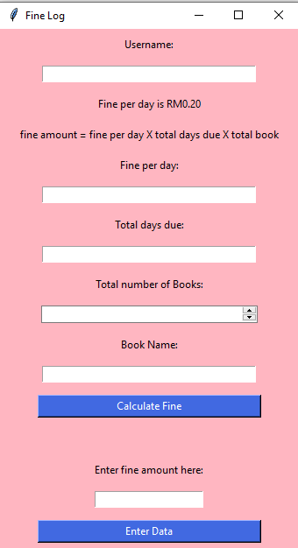
import tkinter as tk
from tkinter import ttk
import sqlite3

def create_table():
conn = sqlite3.connect("fine_system.db")
cursor = conn.cursor()
cursor.execute("CREATE TABLE IF NOT EXISTS fine (username TEXT, fineperday INTEGER, totaldaysdue INTEGER, totalbook INTEGER, bookname TEXT, paymentamount INTEGER)")
conn.commit()
conn.close()

def insert_data():
username = username_entry.get()
fineperday = fineperday_entry.get()
totaldaysdue = totaldaysdue_entry.get()
totalbook = totalbook_spinbox.get()
bookname = bookname_entry.get()
paymentamount = fine_amount_entry.get()

conn = sqlite3.connect("fine_system.db")
cursor = conn.cursor()
cursor.execute("INSERT INTO fine (username, fineperday, totaldaysdue, totalbook, bookname, paymentamount) VALUES (?, ?, ?, ?, ?,?)", (username, fineperday, totaldaysdue, totalbook, bookname,paymentamount))
conn.commit()
conn.close()

username_entry.delete(0, tk.END)
fineperday_entry.delete(0, tk.END)
totaldaysdue_entry.delete(0, tk.END)
totalbook_spinbox.delete(0, tk.END)
bookname_entry.delete(0, tk.END)
fine_amount_entry.delete(0, tk.END)

def fine_amount():
fineperday = 0.20
totaldaysdue = int(totaldaysdue_entry.get())
totalbook = int(totalbook_spinbox.get())
fine = fineperday * totaldaysdue * totalbook

label_output.config(text=f'Total Fine Amount = RM{fine :.2f}')

window = tk.Tk()
window.title("Fine Log")
window.configure(bg="light pink")

frame = tk.Frame(window)
frame.grid()

username_label = tk.Label(window, text="Username:", bg="light pink")
username_label.grid(row=0, column=0)
username_entry = tk.Entry(window, width = 40, justify = "center")
username_entry.grid(row=1, column=0)

fine_label = tk.Label(window, text="Fine per day is RM0.20", bg="light pink")
fine_label.grid(row=2, column=0)

calculate_label = tk.Label(window, text="fine amount = fine per day X total days due X total book", bg="light pink")
calculate_label.grid(row=3, column=0)

fineperday_label = tk.Label(window, text="Fine per day:", bg="light pink")
fineperday_label.grid(row=4, column=0)
fineperday_entry = tk.Entry(window, width = 40, justify = "center")
fineperday_entry.grid(row=5, column=0)

totaldaysdue_label = tk.Label(window, text="Total days due:", bg="light pink")
totaldaysdue_label.grid(row=6, column=0)
totaldaysdue_entry = tk.Entry(window, width = 40, justify = "center")
totaldaysdue_entry.grid(row=7, column=0)

totalbook_label = tk.Label(window, text="Total number of Books:", bg="light pink")
totalbook_label.grid(row=8, column=0)
totalbook_spinbox = ttk.Spinbox(window, from_ = 0, to = 20, width = 38, justify = "center")
totalbook_spinbox.grid(row=9, column=0)

bookname_label = tk.Label(window, text="Book Name:", bg="light pink")
bookname_label.grid(row=10, column=0)
bookname_entry = tk.Entry(window, width = 40, justify = "center")
bookname_entry.grid(row=11, column=0)

payment_button = tk.Button(window, text="Calculate Fine", command=fine_amount, width = 35, bg = "royal blue", fg = "white")
payment_button.grid(row=12, column=0, padx=20, pady=10)

label_output = tk.Label(window, bg="light pink")
label_output.grid(row=13, column=0, padx=20, pady=10)

fine_label = tk.Label(window, text="Enter fine amount here:", bg="light pink")
fine_label.grid(row=14,column=0)

fine_amount_entry = tk.Entry(window)
fine_amount_entry.grid(row = 15, column = 0)

enterdata_button = tk.Button(window, text="Enter Data", command=insert_data, width = 35, bg = "royal blue", fg = "white")
enterdata_button.grid(row=17,column=0, padx=20, pady=10)

for widget in window.winfo_children(): #winfo stands for widget info
widget.grid_configure(padx = 20, pady = 7)

create_table()
window.mainloop()

3.5 displaymembers.py
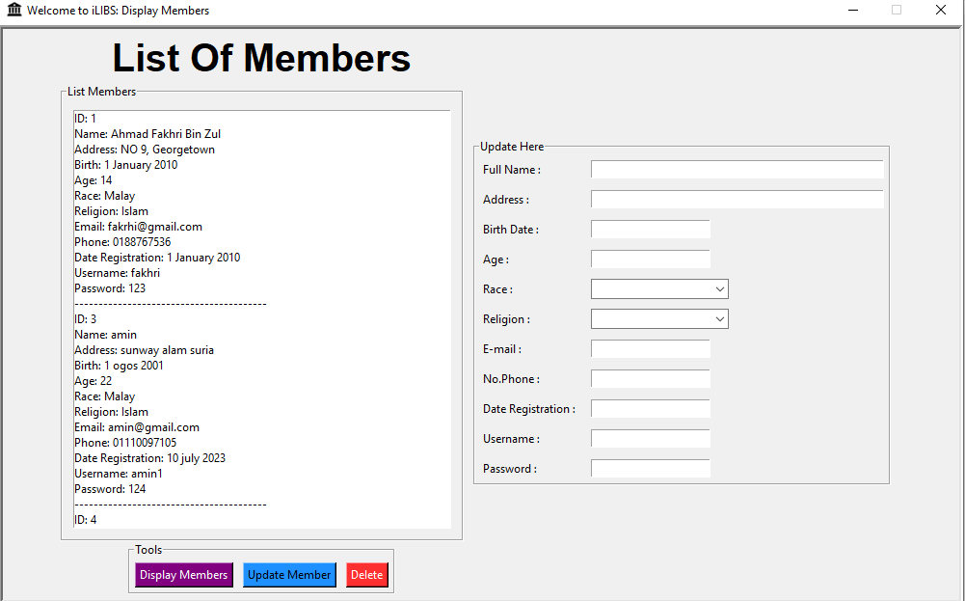
from tkinter import *
import tkinter
import tkinter as tk
from tkinter import ttk, messagebox
import sqlite3

def display_data():

member_name = entry_fullname.get()
member_address = entry_address.get()
member_birth = entry_birth.get()
member_age = entry_age.get()
member_race = entry_race.get()
member_religion = entry_religion.get()
member_email = entry_email.get()
member_phone = entry_phone.get()
member_date = entry_date.get()
member_user = entry_username.get()
member_password = entry_password.get()

conn = sqlite3.connect("database.db")
cursor = conn.cursor()
cursor.execute("SELECT id, member_name, member_address, member_birth, member_age, member_race, member_religion, member_email, member_phone,member_date, member_user, member_pass FROM members")
rows = cursor.fetchall()
conn.close()

listmember_display.delete(0, tk.END)
for row in rows:
id_member, member_name, member_address, member_birth, member_age, member_race, member_religion, member_email, member_phone, member_date, member_user, member_password = row
listmember_display.insert(tk.END, f"ID: {id_member}")
listmember_display.insert(tk.END, f"Name: {member_name}")
listmember_display.insert(tk.END, f"Address: {member_address}")
listmember_display.insert(tk.END, f"Birth: {member_birth}")
listmember_display.insert(tk.END, f"Age: {member_age}")
listmember_display.insert(tk.END, f"Race: {member_race}")
listmember_display.insert(tk.END, f"Religion: {member_religion}")
listmember_display.insert(tk.END, f"Email: {member_email}")
listmember_display.insert(tk.END, f"Phone: {member_phone}")
listmember_display.insert(tk.END, f"Date Registration: {member_date}")
listmember_display.insert(tk.END, f"Username: {member_user}")
listmember_display.insert(tk.END, f"Password: {member_password}")
listmember_display.insert(tk.END, "-" * 40)

def update_data():
selected_item = listmember_display.curselection()

if not selected_item:
return

new_fullname = entry_fullname.get()
new_address = entry_address.get()
new_birthdate = entry_birth.get()
new_age = entry_age.get()
new_race = entry_race.get()
new_religion = entry_religion.get()
new_email = entry_email.get()
new_phone = entry_phone.get()
new_date = entry_date.get()
new_username = entry_username.get()
new_password = entry_password.get()

selected_item_text = listmember_display.get(selected_item[0])
selected_item_id = selected_item_text.split(':')[1].strip()

conn = sqlite3.connect("database.db")
cursor = conn.cursor()
cursor.execute("UPDATE members SET member_name=?, member_address=?, member_birth=?, member_age=?, member_race=?, member_religion=?, member_email=?, member_phone=?, member_date=?, member_user=?, member_pass=? WHERE id=?", (new_fullname, new_address, new_birthdate, new_age, new_race, new_religion, new_email, new_phone, new_date, new_username, new_password, selected_item_id))
conn.commit()
conn.close()

entry_fullname.delete(0, tk.END)
entry_address.delete(0, tk.END)
entry_birth.delete(0, tk.END)
entry_age.delete(0, tk.END)
entry_race.delete(0, tk.END)
entry_religion.delete(0, tk.END)
entry_email.delete(0, tk.END)
entry_phone.delete(0, tk.END)
entry_date.delete(0, tk.END)
entry_username.delete(0, tk.END)
entry_password.delete(0, tk.END)

display_data()

def delete_data():
selected_item = listmember_display.curselection()
if not selected_item:
return

selected_id = listmember_display.get(selected_item).split(":")[1].strip()

conn = sqlite3.connect("database.db")
cursor = conn.cursor()
cursor.execute("DELETE FROM members WHERE id=?", (selected_id,))
conn.commit()
conn.close()

display_data()

# Create the main window
window = tk.Tk()
window.title("Welcome to iLIBS: Display Members")
window.iconbitmap("icons/library.ico")
window.geometry("1000x600")
window.resizable(False,False)
window.configure(relief='sunken', borderwidth=4)

# Set the window size
window_width = 1000
window_height = 600

# Get the screen dimensions
screen_width = window.winfo_screenwidth()
screen_height = window.winfo_screenheight()

# Calculate the coordinates to center the window
x = (screen_width - window_width) // 2
y = (screen_height - window_height) // 2

# Set the window position
window.geometry(f"{window_width}x{window_height}+{x}+{y}")

frame = tkinter.Frame(window,bg="",relief='sunken',borderwidth=4)
frame.pack()

lbl = tkinter.Label(frame, text="List Of Members", font=("arial", 30, "bold"))
lbl.grid(row=0,column=0)

first_frame = tkinter.LabelFrame(frame, text="List Members")
first_frame.grid(row=1,column=0)

second_frame = tkinter.LabelFrame(frame, text="Update Here")
second_frame.grid(row=1,column=1,padx=10)

listmember_display = tkinter.Listbox(first_frame, width=65, height=27)
listmember_display.grid(row=0,column=0, padx=10, pady=10, sticky="news")

toolsframe = tkinter.LabelFrame(frame, text="Tools")
toolsframe.grid(row=2,column=0,padx=10)

display_button = tkinter.Button(toolsframe, text="Display Members", command=display_data, bg="#800080", fg="white")
display_button.grid(row=0,column=0)

update_button = tkinter.Button(toolsframe, text="Update Member", command=update_data, bg="#1E90FF", fg="black")
update_button.grid(row=0,column=1)

delete_button = tkinter.Button(toolsframe, text="Delete", command=delete_data, bg="#FF3030", fg="white")
delete_button.grid(row=0,column=2)

for widget in toolsframe.winfo_children():
widget.grid_configure(padx=5, pady=5)

# second frame
lbl_fullname = tkinter.Label(second_frame, text="Full Name : ")
lbl_fullname.grid(row=0,column=0, sticky="W")

entry_fullname = tkinter.Entry(second_frame, width=50)
entry_fullname.grid(row=0,column=1, sticky="W")

lbl_address = tkinter.Label(second_frame, text="Address : ")
lbl_address.grid(row=1,column=0,sticky="W")

entry_address = tkinter.Entry(second_frame, width=50)
entry_address.grid(row=1,column=1,sticky="W")

lbl_birthdate = tkinter.Label(second_frame, text="Birth Date : ")
lbl_birthdate.grid(row=2,column=0,sticky="W")

entry_birth = tkinter.Entry(second_frame)
entry_birth.grid(row=2,column=1,sticky="W")

lbl_age = tkinter.Label(second_frame, text="Age : ")
lbl_age.grid(row=3,column=0,sticky="W")

entry_age = tkinter.Entry(second_frame)
entry_age.grid(row=3,column=1, sticky="W")

lbl_race = tkinter.Label(second_frame, text="Race : ")
lbl_race.grid(row=4,column=0, sticky="W")

entry_race = ttk.Combobox(second_frame, values=["Malay","Chinese","Indian","Bumiputera","Other"])
entry_race.grid(row=4,column=1, sticky="W")

lbl_religion = tkinter.Label(second_frame, text="Religion : ")
lbl_religion.grid(row=5,column=0,sticky="w")

entry_religion = ttk.Combobox(second_frame, values=["Islam","Christian","Buddha","Hindu","Other"])
entry_religion.grid(row=5,column=1, sticky="W")

lbl_email = tkinter.Label(second_frame, text="E-mail : ")
lbl_email.grid(row=6,column=0,sticky="w")

entry_email = tkinter.Entry(second_frame, width=20)
entry_email.grid(row=6,column=1,sticky="w")

lbl_phone = tkinter.Label(second_frame, text="No.Phone : ")
lbl_phone.grid(row=7,column=0,sticky="w")

entry_phone = tkinter.Entry(second_frame)
entry_phone.grid(row=7,column=1,sticky="w")

lbl_date_registration = tkinter.Label(second_frame, text="Date Registration : ")
lbl_date_registration.grid(row=9,column=0, sticky="W")

entry_date = tkinter.Entry(second_frame)
entry_date.grid(row=9,column=1, sticky="W")

lbl_username = tkinter.Label(second_frame, text="Username : ")
lbl_username.grid(row=10,column=0,sticky="W")

entry_username = tkinter.Entry(second_frame)
entry_username.grid(row=10,column=1,sticky="W")

lbl_password = tkinter.Label(second_frame, text="Password : ")
lbl_password.grid(row=11,column=0,sticky="W")

entry_password = tkinter.Entry(second_frame)
entry_password.grid(row=11,column=1,sticky="W")

for widget in second_frame.winfo_children():
widget.grid_configure(padx=5, pady=5)

# Start the main event loop
window.mainloop()

4.0 ICT Department
4.1 loginict.py
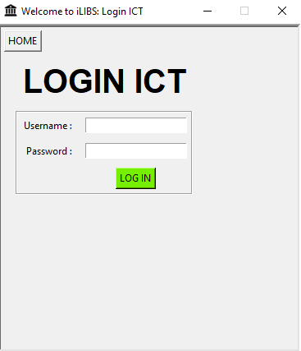
from tkinter import *
import tkinter
import tkinter as tk
from tkinter import messagebox
import sqlite3

def home():
window.destroy()
import main

def login_success():
messagebox.showinfo("Login Successful", "Welcome, Admin!")
entry_username.delete(0, END)
entry_password.delete(0, END)
window.destroy() # Close the login window
import ict

def login():
conn = sqlite3.connect('database.db')
cursor = conn.cursor()

user = entry_username.get()
code = entry_password.get()

query = "SELECT * FROM ict WHERE name = ? AND id = ?"
cursor.execute(query, (user, code))
result = cursor.fetchone()

if result is not None:
# User credentials are valid
login_success()

else:
# Invalid username or password
messagebox.showerror("Login Failed", "Invalid username or password")
entry_username.delete(0, tk.END)
entry_password.delete(0, tk.END)
prompt_try_again()

conn.close()

def prompt_try_again():
result = messagebox.askretrycancel("Try Again", "Do you want to try again?")
if result == True:
entry_password.focus_set() # Set focus back to username entry field
else:
window.destroy() # Close the login window

# Create the main window
window = tk.Tk()
window.title("Welcome to iLIBS: Login ICT")
window.iconbitmap("icons/library.ico")
window.geometry("370x400")
window.resizable(False,False)
window.configure(relief='sunken', borderwidth=4)

# Set the window size
window_width = 370
window_height = 400

# Get the screen dimensions
screen_width = window.winfo_screenwidth()
screen_height = window.winfo_screenheight()

# Calculate the coordinates to center the window
x = (screen_width - window_width) // 2
y = (screen_height - window_height) // 2

# Set the window position
window.geometry(f"{window_width}x{window_height}+{x}+{y}")

frame = tkinter.Frame(window,bg="",relief='sunken',borderwidth=4)
frame.grid()

home_button = tk.Button(frame, text="HOME", command=home)
home_button.grid(row=0,column=0, sticky="W")

login_label = tkinter.Label(frame, text="LOGIN ICT", font=("Arial", 30, "bold"))
login_label.grid(row=1,column=0, padx=20,pady=10)

login_frame = tkinter.LabelFrame(frame)
login_frame.grid(row=2,column=0)

lbl_username = tkinter.Label(login_frame, text="Username : ")
lbl_username.grid(row=0,column=0)

entry_username = tkinter.Entry(login_frame, width=20)
entry_username.grid(row=0,column=1)

lbl_password = Label(login_frame, text="Password :")
lbl_password.grid(row=1,column=0,padx=5,pady=2)
password = StringVar() # Create a StringVar for the password
entry_password = Entry(login_frame, show="*", textvariable=password)
entry_password.grid(row=1,column=1,padx=5,pady=2)

login_button = tkinter.Button(login_frame, text="LOG IN", command=login, bg="#76EE00", fg="black")
login_button.grid(row=3,column=1)

for widget in login_frame.winfo_children():
widget.grid_configure(padx=5, pady=5)

# Start the main event loop
window.mainloop()
4.2 ict.py
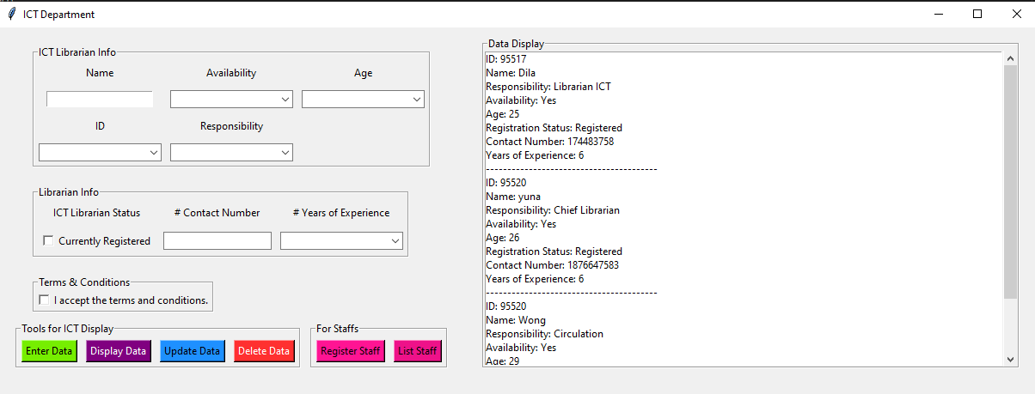
import tkinter
from tkinter import ttk
from tkinter import messagebox
import sqlite3

def reg_staff():
import staffregistration

def list_staff():
import liststaff

def enter_data():
accepted = accept_var.get()

if accepted == "Accepted":
# Librarian info
name = name_entry.get()
responsibility = responsibility_combobox.get()

if name and responsibility:
availability = availability_combobox.get()
age = age_combobox.get()
id = id_combobox.get()

# Librarian ICT info
registration_status = reg_status_var.get()
contactnum = contactnum_combobox.get()
numexperience = numexperience_combobox.get()

print("Name: ", name, "Responsibility: ", responsibility)
print("Availability: ", availability, "Age: ", age, "ID: ", id)
print("# Contact Number: ", contactnum, "# Years of Experience: ", numexperience)
print("Registration status", registration_status)
print("------------------------------------------")

# Create Table
conn = sqlite3.connect('database.db')
table_create_query = '''CREATE TABLE IF NOT EXISTS ict
(name TEXT, responsibility TEXT, availability TEXT, age INT, id TEXT,
registration_status TEXT, contact_num INT, num_experience INT)
'''
conn.execute(table_create_query)

# Insert Data
data_insert_query = '''INSERT INTO ict (name, responsibility, availability,
age, id, registration_status, contact_num , num_experience) VALUES
(?, ?, ?, ?, ?, ?, ?, ?)'''
data_insert_tuple = (name, responsibility, availability,
age, id, registration_status, contactnum, numexperience)
cursor = conn.cursor()
cursor.execute(data_insert_query, data_insert_tuple)
conn.commit()
conn.close()
messagebox.showinfo("Success","Successfully added to database",icon='info')

else:
tkinter.messagebox.showwarning(title="Error", message="Name and responsibility are required.")
else:
tkinter.messagebox.showwarning(title="Error", message="You have not accepted the terms")

def display_data():
# Function to display the data from the database
conn = sqlite3.connect('database.db')
cursor = conn.cursor()
cursor.execute("SELECT * FROM ict")
rows = cursor.fetchall()
conn.close()

display_box.delete(0, tkinter.END)
for row in rows:
name, responsibility, availability, age, id, registration_status, contact_num, num_experience = row
display_box.insert(tkinter.END, f"ID: {id}")
display_box.insert(tkinter.END, f"Name: {name}")
display_box.insert(tkinter.END, f"Responsibility: {responsibility}")
display_box.insert(tkinter.END, f"Availability: {availability}")
display_box.insert(tkinter.END, f"Age: {age}")
display_box.insert(tkinter.END, f"Registration Status: {registration_status}")
display_box.insert(tkinter.END, f"Contact Number: {contact_num}")
display_box.insert(tkinter.END, f"Years of Experience: {num_experience}")
display_box.insert(tkinter.END, "-" * 40)

def update_data():
selected_item = display_box.curselection()

if not selected_item:
return

# Function to update the data in the database
new_id = id_combobox.get()
new_responsibility = responsibility_combobox.get()
new_name = name_entry.get()
new_availability = availability_combobox.get()
new_age = age_combobox.get()
new_contactnum = contactnum_combobox.get()
new_numexperience = numexperience_combobox.get()

selected_item_text = display_box.get(selected_item[0])
selected_item_id = selected_item_text.split(':')[1].strip()

conn = sqlite3.connect('database.db')
cursor = conn.cursor()
cursor.execute("UPDATE ict SET name=?, responsibility=?, availability=?, age=?, contact_num=?, num_experience=? WHERE id=?", (new_id, new_name, new_responsibility, new_availability, new_age, new_contactnum, new_numexperience, selected_item_id))
conn.commit()
print("Data updated successfully.")

display_data() # Update the data displayed in the interface
conn.close()

def delete_data():
selected_item = display_box.curselection()
if not selected_item:
return

selected_text = display_box.get(selected_item[0])
selected_id = selected_text.split(":")[1].strip()

conn = sqlite3.connect('database.db')
cursor = conn.cursor()
cursor.execute("DELETE FROM ict WHERE id = ?", (selected_id,))
conn.commit()
conn.close()
print("Data deleted successfully.")

display_data()

window = tkinter.Tk()
window.title("ICT Department")

accept_var = tkinter.StringVar(value="Not Accepted")

frame = tkinter.Frame(window)
frame.grid(row=0, column=0, sticky="w", padx=20, pady=10)

# ICT Librarian Details
librarian_frame = tkinter.LabelFrame(frame, text="ICT Librarian Info")
librarian_frame.grid(row= 0, column=0, sticky="w", padx=20, pady=10)

name_label = tkinter.Label(librarian_frame, text="Name")
name_entry = tkinter.Entry(librarian_frame)
name_label.grid(row=0, column=0)
name_entry.grid(row=1, column=0)

availability_label = tkinter.Label(librarian_frame, text="Availability")
availability_combobox = ttk.Combobox(librarian_frame, values=["", "Yes", "No"])
availability_label.grid(row=0, column=1)
availability_combobox.grid(row=1, column=1)

age_label = tkinter.Label(librarian_frame, text="Age")
age_combobox = ttk.Combobox(librarian_frame, values=[str(i) for i in range(25, 41)])
age_label.grid(row=0, column=2)
age_combobox.grid(row=1, column=2)

id_label = tkinter.Label(librarian_frame, text="ID")
id_combobox = ttk.Combobox(librarian_frame, values=["95517", "95519", "95520", "95521", "95528", "96610", "96615",
"96627", "96630", "96634"])
id_label.grid(row=2, column=0)
id_combobox.grid(row=3, column=0)

responsibility_label = tkinter.Label(librarian_frame, text="Responsibility")
responsibility_combobox = ttk.Combobox(librarian_frame, values=["Cataloging", "Acquisition", "Librarian ICT", "Corporate Unit",
"Documentation Unit", "Circulation", "Financial Unit",
"Chief Librarian", "Assistant Librarian"])
responsibility_label.grid(row=2, column=1)
responsibility_combobox.grid(row=3, column=1)

for widget in librarian_frame.winfo_children():
widget.grid_configure(padx=5, pady=5)

librarian_frame = tkinter.LabelFrame(frame, text="Librarian Info")
librarian_frame.grid(row=1, column=0, sticky="w", padx=20, pady=10)

registered_label = tkinter.Label(librarian_frame, text="ICT Librarian Status")
reg_status_var = tkinter.StringVar(value="Not Registered")
registered_check = tkinter.Checkbutton(librarian_frame, text="Currently Registered",
variable=reg_status_var, onvalue="Registered", offvalue="Not Registered")
registered_label.grid(row=0, column=0)
registered_check.grid(row=1, column=0)

contactnum_label = tkinter.Label(librarian_frame, text="# Contact Number")
contactnum_combobox = ttk.Entry(librarian_frame)
contactnum_label.grid(row=0, column=1)
contactnum_combobox.grid(row=1, column=1)

numexperience_label = tkinter.Label(librarian_frame, text="# Years of Experience")
numexperience_combobox = ttk.Combobox(librarian_frame, values=["5", "6", "7", "8", "9", "10", "11", "12", "13", "14", "15",
"16", "17", "18", "19", "20", "21", "22", "23", "24", "25",
"26", "27", "28", "29", "30", "31", "32", "33", "34", "35",
"36", "37", "38", "39", "40"])
numexperience_label.grid(row=0, column=2)
numexperience_combobox.grid(row=1, column=2)

for widget in librarian_frame.winfo_children():
widget.grid_configure(padx=5, pady=5)

# Buttons
button_frame = tkinter.Frame(window)
button_frame.grid(row=3, column=0, sticky="w", padx=20, pady=10)

tool_bar = tkinter.LabelFrame(frame, text="Tools for ICT Display")
tool_bar.grid(row=3, column=0, sticky="W")

enter_button = tkinter.Button(tool_bar, text="Enter Data", command=enter_data, bg="#76EE00", fg="black")
enter_button.grid(row=0, column=0, padx=5)

display_button = tkinter.Button(tool_bar, text="Display Data", command=display_data, bg="#800080", fg="white")
display_button.grid(row=0, column=1, padx=5)

update_button = tkinter.Button(tool_bar, text="Update Data", command=update_data, bg="#1E90FF", fg="black")
update_button.grid(row=0, column=2, padx=5)

delete_button = tkinter.Button(tool_bar, text="Delete Data", command=delete_data, bg="#FF3030", fg="white")
delete_button.grid(row=0, column=3, padx=5)

for widget in tool_bar.winfo_children():
widget.grid_configure(padx=5, pady=5)

staff_frame = tkinter.LabelFrame(frame, text="For Staffs")
staff_frame.grid(row=3,column=0, sticky="E")

registerstaff_button = tkinter.Button(staff_frame, text="Register Staff", bg="deeppink1", command=reg_staff)
registerstaff_button.grid(row=0, column=0, padx=5)

liststaff_button = tkinter.Button(staff_frame, text="List Staff", bg="deeppink2", command=list_staff)
liststaff_button.grid(row=0,column=1, padx=5)

for widget in staff_frame.winfo_children():
widget.grid_configure(padx=5, pady=5)

# Accept terms
terms_frame = tkinter.LabelFrame(frame, text="Terms & Conditions")
terms_frame.grid(row=2, column=0, sticky="w", padx=20, pady=10)

terms_check = tkinter.Checkbutton(terms_frame, text="I accept the terms and conditions.",
variable=accept_var, onvalue="Accepted", offvalue="Not Accepted")
terms_check.grid(row=0, column=0)

# Display Data Box
display_frame = tkinter.LabelFrame(window, text="Data Display")
display_frame.grid(row=0, column=1, rowspan=3, sticky="news", padx=20, pady=10)

scrollbar = tkinter.Scrollbar(display_frame)
scrollbar.pack(side="right", fill="y")

display_box = tkinter.Listbox(display_frame, yscrollcommand=scrollbar.set, width=100)
display_box.pack(side="left", fill="both")

scrollbar.config(command=display_box.yview)

window.mainloop()

4.3 staffregistration.py
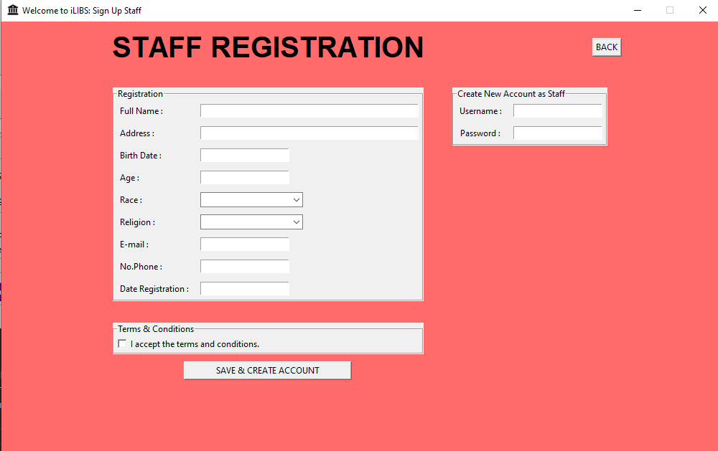
import tkinter
import tkinter as tk
from tkinter import ttk, messagebox
import sqlite3

def back():
window.destroy()
import ict

def create_table():
conn = sqlite3.connect("database.db")
cursor = conn.cursor()
cursor.execute("CREATE TABLE IF NOT EXISTS staff (id INTEGER PRIMARY KEY AUTOINCREMENT, staff_name TEXT, staff_address TEXT, staff_birth TEXT, staff_age INTEGER, staff_race TEXT, staff_religion TEXT, staff_email TEXT, staff_phone TEXT, staff_user TEXT, staff_date TEXT, staff_pass TEXT)")
conn.commit()
conn.close()

def insert_data():
accepted = accept_var.get()

if accepted=="Accepted":
staff_name = entry_fullname.get()
staff_address = entry_address.get()
staff_birth = entry_birth.get()
staff_age = entry_age.get()
staff_race = entry_race.get()
staff_religion = entry_religion.get()
staff_email = entry_email.get()
staff_phone = entry_phone.get()
staff_date = entry_date.get()
staff_user = entry_username.get()
staff_pass = entry_password.get()

if staff_name and staff_address and staff_birth and staff_age and staff_race and staff_religion and staff_email and staff_phone and staff_date and staff_user and staff_pass:

conn = sqlite3.connect("database.db")
cursor = conn.cursor()
cursor.execute("INSERT INTO staff (staff_name,staff_address,staff_birth,staff_age,staff_race,staff_religion,staff_email,staff_phone,staff_date,staff_user,staff_pass) VALUES(?,?,?,?,?,?,?,?,?,?,?)",(staff_name,staff_address,staff_birth,staff_age,staff_race,staff_religion,staff_email,staff_phone,staff_date,staff_user,staff_pass))
conn.commit()
conn.close()
messagebox.showinfo("Success","Successfully added to database",icon='info')

entry_fullname.delete(0,tk.END)
entry_address.delete(0,tk.END)
entry_birth.delete(0,tk.END)
entry_age.delete(0,tk.END)
entry_race.delete(0,tk.END)
entry_religion.delete(0,tk.END)
entry_email.delete(0,tk.END)
entry_phone.delete(0,tk.END)
entry_date.delete(0,tk.END)
entry_username.delete(0,tk.END)
entry_password.delete(0,tk.END)
else:
tkinter.messagebox.showwarning(title="Error", message="Fields cannot be empty", icon="warning")
else:
tkinter.messagebox.showwarning(title= "Error", message="You have not accepted the terms", icon="warning")

# Main Window
window = tk.Tk()
window.title("Welcome to iLIBS: Sign Up Staff")
window.geometry("1000x600")
window.iconbitmap("icons/library.ico")
window.resizable(False,False)
window.configure(bg="#FF6A6A")

# Set the window size
window_width = 1000
window_height = 600

# Get the screen dimensions
screen_width = window.winfo_screenwidth()
screen_height = window.winfo_screenheight()

# Calculate the coordinates to center the window
x = (screen_width - window_width) // 2
y = (screen_height - window_height) // 2

# Set the window position
window.geometry(f"{window_width}x{window_height}+{x}+{y}")

# Main Frame
frame = tkinter.Frame(window, bg="#FF6A6A")
frame.pack()

home_buttom = tkinter.Button(frame, text="BACK",command=back)
home_buttom.grid(row=0,column=1,sticky="E")

lbl1 = tkinter.Label(frame, text="STAFF REGISTRATION", font=("Arial", 30, "bold"), bg="#FF6A6A")
lbl1.grid(row=0,column=0,padx=10,pady=10)

# Registration/Payment Frame
membership_frame = tkinter.LabelFrame(frame, text="Registration")
membership_frame.grid(row=1,column=0, sticky="news", padx=20,pady=20)

lbl_fullname = tkinter.Label(membership_frame, text="Full Name : ")
lbl_fullname.grid(row=0,column=0, sticky="W")

entry_fullname = tkinter.Entry(membership_frame, width=50)
entry_fullname.grid(row=0,column=1, sticky="W")

lbl_address = tkinter.Label(membership_frame, text="Address : ")
lbl_address.grid(row=1,column=0,sticky="W")

entry_address = tkinter.Entry(membership_frame, width=50)
entry_address.grid(row=1,column=1,sticky="W")

lbl_birthdate = tkinter.Label(membership_frame, text="Birth Date : ")
lbl_birthdate.grid(row=2,column=0,sticky="W")

entry_birth = tkinter.Entry(membership_frame)
entry_birth.grid(row=2,column=1,sticky="W")

lbl_age = tkinter.Label(membership_frame, text="Age : ")
lbl_age.grid(row=3,column=0,sticky="W")

entry_age = tkinter.Entry(membership_frame)
entry_age.grid(row=3,column=1, sticky="W")

lbl_race = tkinter.Label(membership_frame, text="Race : ")
lbl_race.grid(row=4,column=0, sticky="W")

entry_race = ttk.Combobox(membership_frame, values=["Malay","Chinese","Indian","Bumiputera","Other"])
entry_race.grid(row=4,column=1, sticky="W")

lbl_religion = tkinter.Label(membership_frame, text="Religion : ")
lbl_religion.grid(row=5,column=0,sticky="w")

entry_religion = ttk.Combobox(membership_frame, values=["Islam","Christian","Buddha","Hindu","Other"])
entry_religion.grid(row=5,column=1, sticky="W")

lbl_email = tkinter.Label(membership_frame, text="E-mail : ")
lbl_email.grid(row=6,column=0,sticky="w")

entry_email = tkinter.Entry(membership_frame, width=20)
entry_email.grid(row=6,column=1,sticky="w")

lbl_date_registration = tkinter.Label(membership_frame, text="Date Registration : ")
lbl_date_registration.grid(row=9,column=0, sticky="W")

entry_date = tkinter.Entry(membership_frame)
entry_date.grid(row=9,column=1, sticky="W")

lbl_phone = tkinter.Label(membership_frame, text="No.Phone : ")
lbl_phone.grid(row=7,column=0,sticky="w")

entry_phone = tkinter.Entry(membership_frame)
entry_phone.grid(row=7,column=1,sticky="w")

for widget in membership_frame.winfo_children():
widget.grid_configure(padx=5, pady=5)

# Account Frame
account_frame = tkinter.LabelFrame(frame, text="Create New Account as Staff")
account_frame.grid(row=1,column=1, padx=20,pady=20, sticky="NW")

lbl_username = tkinter.Label(account_frame, text="Username : ")
lbl_username.grid(row=0,column=0,sticky="W")

entry_username = tkinter.Entry(account_frame)
entry_username.grid(row=0,column=1,sticky="W")

lbl_password = tkinter.Label(account_frame, text="Password : ")
lbl_password.grid(row=1,column=0)

entry_password = tkinter.Entry(account_frame)
entry_password.grid(row=1,column=1)

for widget in account_frame.winfo_children():
widget.grid_configure(padx=5, pady=5)

# ACCEPT TERMS FRAME
terms_frame = tkinter.LabelFrame(frame, text="Terms & Conditions")
terms_frame.grid(row=2, column=0, sticky="news", padx=20, pady=10)

accept_var = tkinter.StringVar(value="Not Accepted")
terms_check = tkinter.Checkbutton(terms_frame, text="I accept the terms and conditions.", variable=accept_var, onvalue="Accepted", offvalue="Not Accepted")
terms_check.grid(row=0, column=0)

save_button = tkinter.Button(frame, text="SAVE & CREATE ACCOUNT", command=insert_data)
save_button.grid(row=3,column=0,ipadx=40, sticky="N")

create_table()

window.mainloop()

4.4 liststaff.py
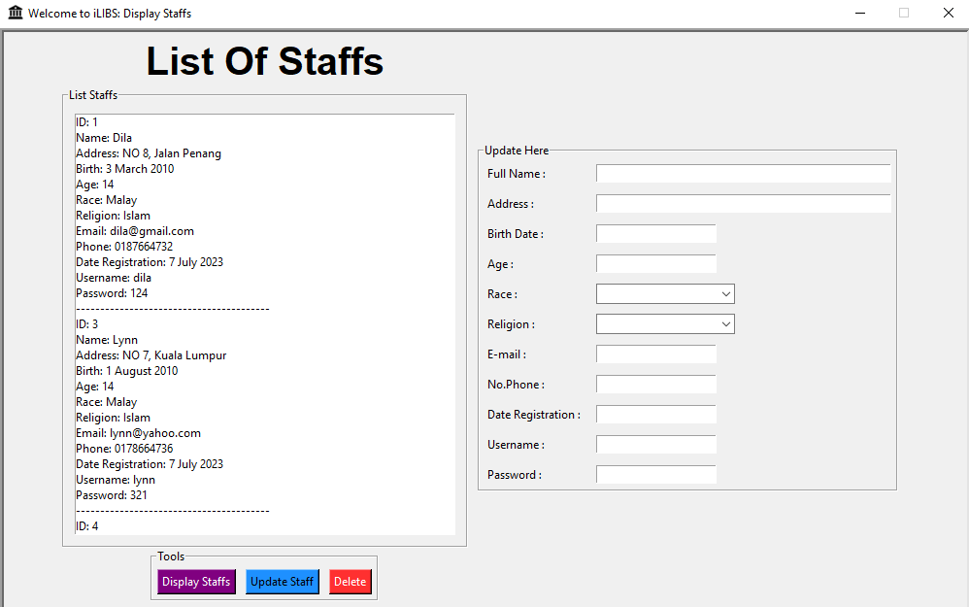
from tkinter import *
import tkinter
import tkinter as tk
from tkinter import ttk, messagebox
import sqlite3

def display_data():

staff_name = entry_fullname.get()
staff_address = entry_address.get()
staff_birth = entry_birth.get()
staff_age = entry_age.get()
staff_race = entry_race.get()
staff_religion = entry_religion.get()
staff_email = entry_email.get()
staff_phone = entry_phone.get()
staff_date = entry_date.get()
staff_user = entry_username.get()
staff_password = entry_password.get()

conn = sqlite3.connect("database.db")
cursor = conn.cursor()
cursor.execute("SELECT id, staff_name, staff_address, staff_birth, staff_age, staff_race, staff_religion, staff_email, staff_phone,staff_date, staff_user, staff_pass FROM staff")
rows = cursor.fetchall()
conn.close()

liststaff_display.delete(0, tk.END)
for row in rows:
id_staff, staff_name, staff_address, staff_birth, staff_age, staff_race, staff_religion,staff_email, staff_phone, staff_date, staff_user, staff_password = row
liststaff_display.insert(tk.END, f"ID: {id_staff}")
liststaff_display.insert(tk.END, f"Name: {staff_name}")
liststaff_display.insert(tk.END, f"Address: {staff_address}")
liststaff_display.insert(tk.END, f"Birth: {staff_birth}")
liststaff_display.insert(tk.END, f"Age: {staff_age}")
liststaff_display.insert(tk.END, f"Race: {staff_race}")
liststaff_display.insert(tk.END, f"Religion: {staff_religion}")
liststaff_display.insert(tk.END, f"Email: {staff_email}")
liststaff_display.insert(tk.END, f"Phone: {staff_phone}")
liststaff_display.insert(tk.END, f"Date Registration: {staff_date}")
liststaff_display.insert(tk.END, f"Username: {staff_user}")
liststaff_display.insert(tk.END, f"Password: {staff_password}")
liststaff_display.insert(tk.END, "-" * 40)

def update_data():
selected_item = liststaff_display.curselection()

if not selected_item:
return

new_fullname = entry_fullname.get()
new_address = entry_address.get()
new_birthdate = entry_birth.get()
new_age = entry_age.get()
new_race = entry_race.get()
new_religion = entry_religion.get()
new_email = entry_email.get()
new_phone = entry_phone.get()
new_date = entry_date.get()
new_username = entry_username.get()
new_password = entry_password.get()

selected_item_text = liststaff_display.get(selected_item[0])
selected_item_id = selected_item_text.split(':')[1].strip()

conn = sqlite3.connect("database.db")
cursor = conn.cursor()
cursor.execute("UPDATE staff SET staff_name=?, staff_address=?, staff_birth=?, staff_age=?, staff_race=?, staff_religion=?, staff_email=?, staff_phone=?, staff_date=?, staff_user=?, staff_pass=? WHERE id=?", (new_fullname, new_address, new_birthdate, new_age, new_race, new_religion, new_email, new_phone, new_date, new_username, new_password, selected_item_id))
conn.commit()
conn.close()

entry_fullname.delete(0, tk.END)
entry_address.delete(0, tk.END)
entry_birth.delete(0, tk.END)
entry_age.delete(0, tk.END)
entry_race.delete(0, tk.END)
entry_religion.delete(0, tk.END)
entry_email.delete(0, tk.END)
entry_phone.delete(0, tk.END)
entry_date.delete(0, tk.END)
entry_username.delete(0, tk.END)
entry_password.delete(0, tk.END)

display_data()

def delete_data():
selected_item = liststaff_display.curselection()
if not selected_item:
return

selected_id = liststaff_display.get(selected_item).split(":")[1].strip()

conn = sqlite3.connect("database.db")
cursor = conn.cursor()
cursor.execute("DELETE FROM staff WHERE id=?", (selected_id,))
conn.commit()
conn.close()

display_data()

# Create the main window
window = tk.Tk()
window.title("Welcome to iLIBS: Display Staffs")
window.iconbitmap("icons/library.ico")
window.geometry("1000x600")
window.resizable(False,False)
window.configure(relief='sunken', borderwidth=4)

# Set the window size
window_width = 1000
window_height = 600

# Get the screen dimensions
screen_width = window.winfo_screenwidth()
screen_height = window.winfo_screenheight()

# Calculate the coordinates to center the window
x = (screen_width - window_width) // 2
y = (screen_height - window_height) // 2

# Set the window position
window.geometry(f"{window_width}x{window_height}+{x}+{y}")

frame = tkinter.Frame(window,bg="",relief='sunken',borderwidth=4)
frame.pack()

lbl = tkinter.Label(frame, text="List Of Staffs", font=("arial", 30, "bold"))
lbl.grid(row=0,column=0)

first_frame = tkinter.LabelFrame(frame, text="List Staffs")
first_frame.grid(row=1,column=0)

second_frame = tkinter.LabelFrame(frame, text="Update Here")
second_frame.grid(row=1,column=1,padx=10)

liststaff_display = tkinter.Listbox(first_frame, width=65, height=27)
liststaff_display.grid(row=0,column=0, padx=10, pady=10, sticky="news")

toolsframe = tkinter.LabelFrame(frame, text="Tools")
toolsframe.grid(row=2,column=0,padx=10)

display_button = tkinter.Button(toolsframe, text="Display Staffs", command=display_data, bg="#800080", fg="white")
display_button.grid(row=0,column=0)

update_button = tkinter.Button(toolsframe, text="Update Staff", command=update_data, bg="#1E90FF", fg="black")
update_button.grid(row=0,column=1)

delete_button = tkinter.Button(toolsframe, text="Delete", command=delete_data, bg="#FF3030", fg="white")
delete_button.grid(row=0,column=2)

for widget in toolsframe.winfo_children():
widget.grid_configure(padx=5, pady=5)

# second frame

lbl_fullname = tkinter.Label(second_frame, text="Full Name : ")
lbl_fullname.grid(row=0,column=0, sticky="W")

entry_fullname = tkinter.Entry(second_frame, width=50)
entry_fullname.grid(row=0,column=1, sticky="W")

lbl_address = tkinter.Label(second_frame, text="Address : ")
lbl_address.grid(row=1,column=0,sticky="W")

entry_address = tkinter.Entry(second_frame, width=50)
entry_address.grid(row=1,column=1,sticky="W")

lbl_birthdate = tkinter.Label(second_frame, text="Birth Date : ")
lbl_birthdate.grid(row=2,column=0,sticky="W")

entry_birth = tkinter.Entry(second_frame)
entry_birth.grid(row=2,column=1,sticky="W")

lbl_age = tkinter.Label(second_frame, text="Age : ")
lbl_age.grid(row=3,column=0,sticky="W")

entry_age = tkinter.Entry(second_frame)
entry_age.grid(row=3,column=1, sticky="W")

lbl_race = tkinter.Label(second_frame, text="Race : ")
lbl_race.grid(row=4,column=0, sticky="W")

entry_race = ttk.Combobox(second_frame, values=["Malay","Chinese","Indian","Bumiputera","Other"])
entry_race.grid(row=4,column=1, sticky="W")

lbl_religion = tkinter.Label(second_frame, text="Religion : ")
lbl_religion.grid(row=5,column=0,sticky="w")

entry_religion = ttk.Combobox(second_frame, values=["Islam","Christian","Buddha","Hindu","Other"])
entry_religion.grid(row=5,column=1, sticky="W")

lbl_email = tkinter.Label(second_frame, text="E-mail : ")
lbl_email.grid(row=6,column=0,sticky="w")

entry_email = tkinter.Entry(second_frame, width=20)
entry_email.grid(row=6,column=1,sticky="w")

lbl_date_registration = tkinter.Label(second_frame, text="Date Registration : ")
lbl_date_registration.grid(row=9,column=0, sticky="W")

entry_date = tkinter.Entry(second_frame)
entry_date.grid(row=9,column=1, sticky="W")

lbl_phone = tkinter.Label(second_frame, text="No.Phone : ")
lbl_phone.grid(row=7,column=0,sticky="w")

entry_phone = tkinter.Entry(second_frame)
entry_phone.grid(row=7,column=1,sticky="w")

for widget in second_frame.winfo_children():
widget.grid_configure(padx=5, pady=5)

lbl_username = tkinter.Label(second_frame, text="Username : ")
lbl_username.grid(row=10,column=0,sticky="W")

entry_username = tkinter.Entry(second_frame)
entry_username.grid(row=10,column=1,sticky="W")

lbl_password = tkinter.Label(second_frame, text="Password : ")
lbl_password.grid(row=11,column=0,sticky="W")

entry_password = tkinter.Entry(second_frame)
entry_password.grid(row=11,column=1,sticky="W")

for widget in second_frame.winfo_children():
widget.grid_configure(padx=5, pady=5)

# Start the main event loop
window.mainloop()

DATABASES

5.1 database.db
Tables (5)
Name | Type | Schema
books |  | CREATE TABLE "books" ( "id" INTEGER, "title" TEXT, "author" TEXT, "publisher" TEXT, "department" TEXT, "isbn" TEXT, "noshelf" TEXT, "status" INTEGER, "member_name" TEXT, "member_id" INTEGER,  PRIMARY KEY("id" AUTOINCREMENT) )
id | INTEGER | "id" INTEGER
title | TEXT | "title" TEXT
author | TEXT | "author" TEXT
publisher | TEXT | "publisher" TEXT
department | TEXT | "department" TEXT
isbn | TEXT | "isbn" TEXT
noshelf | TEXT | "noshelf" TEXT
status | INTEGER | "status" INTEGER
member_name | TEXT | "member_name" TEXT
member_id | INTEGER | "member_id" INTEGER
ict | CREATE TABLE ict (name TEXT, responsibility TEXT, availability TEXT, age INT, id TEXT, registration_status TEXT, contact_num  INT, num_experience INT)
name | TEXT | "name" TEXT
responsibility | TEXT | "responsibility" TEXT
availability | TEXT | "availability" TEXT
age | INT | "age" INT
id | TEXT | "id" TEXT
registration_status | TEXT | "registration_status" TEXT
contact_num | INT | "contact_num" INT
num_experience | INT | "num_experience" INT
members |  | CREATE TABLE members (id INTEGER PRIMARY KEY AUTOINCREMENT,  member_name TEXT, member_address TEXT, member_birth TEXT, member_age INTEGER, member_race TEXT, member_religion TEXT, member_email TEXT, member_phone TEXT, member_user TEXT,  member_date TEXT, member_pass TEXT)
id | INTEGER | "id" INTEGER
member_name | TEXT | "member_name" TEXT
member_address | TEXT | "member_address" TEXT
member_birth | TEXT | "member_birth" TEXT
member_age | INTEGER | "member_age" INTEGER
member_race | TEXT | "member_race" TEXT
member_religion | TEXT | "member_religion" TEXT
member_email | TEXT | "member_email" TEXT
member_phone | TEXT | "member_phone" TEXT
member_user | TEXT | "member_user" TEXT
member_date | TEXT | "member_date" TEXT
member_pass | TEXT | "member_pass" TEXT
sqlite_sequence |  | CREATE TABLE sqlite_sequence(name,seq)
name |  | "name"
seq |  | "seq"
staff |  | CREATE TABLE staff (id INTEGER PRIMARY KEY AUTOINCREMENT,
Name | Type | Schema
staff_name TEXT, staff_address TEXT, staff_birth TEXT, staff_age INTEGER, staff_race TEXT, staff_religion TEXT, staff_email TEXT, staff_phone TEXT, staff_user TEXT, staff_date TEXT, staff_pass
TEXT)
id | INTEGER | "id" INTEGER
staff_name | TEXT | "staff_name" TEXT
staff_address | TEXT | "staff_address" TEXT
staff_birth | TEXT | "staff_birth" TEXT
staff_age | INTEGER | "staff_age" INTEGER
staff_race | TEXT | "staff_race" TEXT
staff_religion | TEXT | "staff_religion" TEXT
staff_email | TEXT | "staff_email" TEXT
staff_phone | TEXT | "staff_phone" TEXT
staff_user | TEXT | "staff_user" TEXT
staff_date | TEXT | "staff_date" TEXT
staff_pass | TEXT | "staff_pass" TEXT
Indices (0)
Name | Type | Schema
Views (0)
Name | Type | Schema
Triggers (0)
Name | Type | Schema

id | title |  | author | publisher | departme nt | isbn | noshelf | status  1  0 | member_nam e | member_id
1 | Adam dan Hawa |  | Ahmad | 88  Company | Collection | 879879 | GH567  YU67 YU78 | status  1  0
2 | Informatio n Security |  | Yuna | Trex GO | REFERENC E | 98312938 | GH567  YU67 YU78 | status  1  0 | joe | 12
3 | DOOM |  | Tan Ji R | Garfield io | Collection | 967987 | GH567  YU67 YU78 | 0
5 | Yusuf Taiyob |  | Shekh Muhamma d | Hon | REFERENC E | 7287398 | YU67 | 0 | pikah | 9
6 | Pengurus |  | Ab. Aziz | Pearson | Business | 98392364 | HD58 | 1
 | dan |  | Yusof | Education |  | 66
 | Gelagat
 | Organisasi
 | di abad ke
 | 21
7 | Starry |  | Neil | Henry Holt | Non- | 97846557 | BN09 | 1
 | Messenge |  | deGrasse | and Co. | Fiction | 386
 | r: Cosmic |  | Tyson
 | Perspectiv
 | es on
 | Civilization
8 | Advancem |  | Punit | Jaipur | Informatio | 97881894 | Z699 | 1
 | ent in |  | Ralhan | Oxford | n | 73556
 | Library & |  |  | Book | Managem
 | Informatio |  |  | Company | ent
 | n Science
9 | The |  | Frances C. | Westport | Library | 15630889 | Z689 | 1
 | Complete |  | Wilkison | Libraries | Managem | 24
 | Guide to |  | and Linda | Unlimited | ent
 | Acquistion |  | K. Lewis
 | Managem
 | ent
11 | Rio |  | KESHI | Wonder | Adult | 7239847 | UI7 | 1
 |  |  |  | book | Collection
12 | Lynn |  | Suzuki | Lynn | Comic | 67687 | UI8 | 0
 | Suzuki
Table : books

Table : ict
name | responsibility | availability | age | id | registration_status | contact_num | num_experience
Dila | Librarian ICT | Yes | 25 95517 |  | Registered | 174483758 | 6
yuna | Chief Librarian | Yes | 26 | 95520 | Registered | 1876647583 | 6
Wong | Circulation | Yes | 29 | 95520 | Registered | 18764324234 | 8

Table : members

id | member  _name | member  _addres s | member  _birth | member  _age | member  _race | member  _religion | member  _email | member  _phone | member  _user | member  _date | member  _pass
1 | Ahmad Fakhri Bin Zul | NO 9,  Georget own | 1  January 2010 | 14 | Malay | Islam | fakrhi@g mail.com | 0188767  536 | fakhri | 1  January 2010 | 123
3 | amin | sunway alam suria | 1 ogos  2001 | 22 | Malay | Islam | amin@g mail.com | 0111009  7105 | amin1 | 10 july  2023 | 124
4 | Latif | No 9,  Jalan Kuala Lumpur | 10 July  2002 | 12 | Malay | Islam | latif@gm ail.com | 0177867  536 | latif | 7  January 2023 | 123

Table : staff
id | staff_na me | staff_ad dress | staff_bir th | staff_ag e | staff_rac e | staff_reli gion | staff_em ail | staff_ph one | staff_us er | staff_da te | staff_pa ss
1 | Dila | NO 8, | 3 March | 14 | Malay | Islam | dila@gm | 0187664 | dila | 7 July | 124
 |  | Jalan | 2010 |  |  |  | ail.com | 732 |  | 2023
 |  | Penang
3 | Lynn | NO 7, | 1 August | 14 | Malay | Islam | lynn@ya | 0178664 | lynn | 7 July | 321
 |  | Kuala | 2010 |  |  |  | hoo.com | 736 |  | 2023
 |  | Lumpur
4 | fio | NO 4, | 8 Mei | 14 | Bumipute | Christian | fio@gmai | 0176574 | fio | 7 July | 456
 |  | Sabah | 2010 |  | ra |  | l.com | 85 |  | 2023

Table : sqlite_sequence
name | seq
members | 4
staff | 4
books | 12
5.2 fine_system.db

Tables (1)
Name | Type | Schema
fine |  | CREATE TABLE fine (username TEXT, fineperday INTEGER, totaldaysdue INTEGER, totalbook INTEGER, bookname TEXT, paymentamount INTEGER)
username | TEXT | "username" TEXT
fineperday | INTEGER | "fineperday" INTEGER
totaldaysdue | INTEGER | "totaldaysdue" INTEGER
totalbook | INTEGER | "totalbook" INTEGER
bookname | TEXT | "bookname" TEXT
paymentamount | INTEGER | "paymentamount" INTEGER
Indices (0)
Name | Type | Schema
Views (0)
Name | Type | Schema
Triggers (0)
Name | Type | Schema

Table: fine

username | fineperday | totaldaysdue | totalbook | bookname | paymentamount
sakinah | 0.2 | 5 | 5 | rapunzel | 5
aini | 0.2 | 3 | 3 | ikan | 1.8
amin | 0.2 | 2 | 2 | masakan melayu tradisional | 0.8
Dila | 0.2 | 2 | 1 | Information | 0.4
Wani | 0.2 | 3 | 2 | Wonder Woman | 1.2
Zulaikha | 0.2 | 2 | 1 | Gajah | 0.4

5.3 bank.db

Tables (2)
Name | Type | Schema
list_acc | CREATE TABLE "list_acc" ( "account_number" INTEGER, "pass_acc" TEXT, "fund" INTEGER, PRIMARY  KEY("account_number" AUTOINCREMENT) )
account_number | INTEGER | "account_number" INTEGER
pass_acc | TEXT | "pass_acc" TEXT
fund | INTEGER | "fund" INTEGER
sqlite_sequence |  | CREATE TABLE sqlite_sequence(name,seq)
name |  | "name"
seq |  | "seq"
Indices (0)
Name | Type | Schema
Views (0)
Name | Type | Schema
Triggers (0)
Name | Type | Schema

Table: list_acc

account_number | pass_acc | fund
1 | 123 | 990

Table: sqlite_sequence

name | seq
list_acc | 1

